Name: Ayushi Nasare
PRN: 24070521174
Experiment No. 1
Experiment Title: Demonstrate inline, internal, and external JavaScript; use console methods; create a webpage showing user info and a welcome message.
Software/Tools Required:
- Visual Studio Code (VS Code)
- Google Chrome
- HTML5
- JavaScript
Experiment Program Code:
index.html
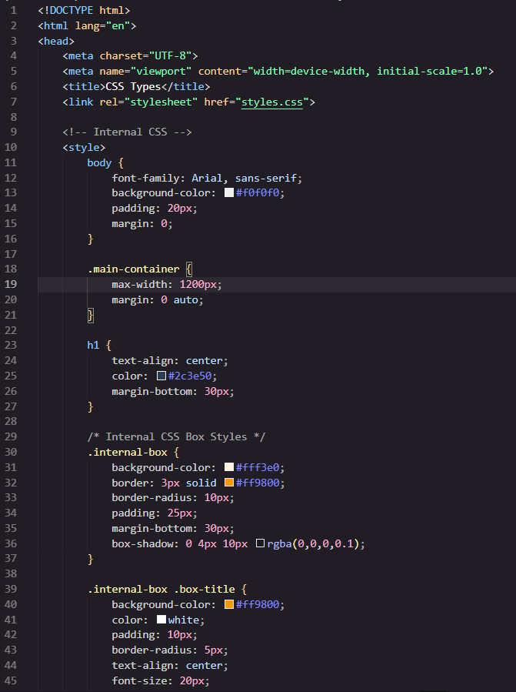
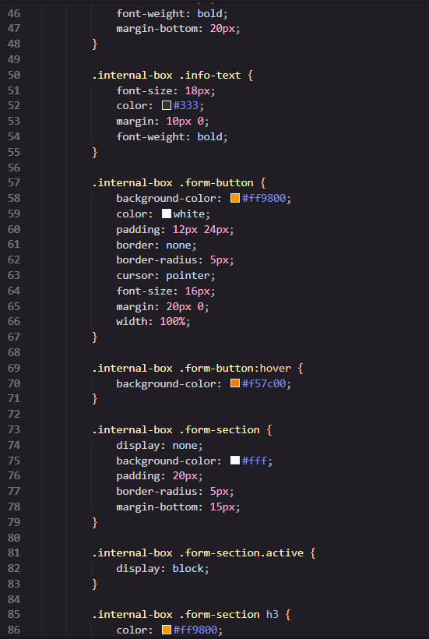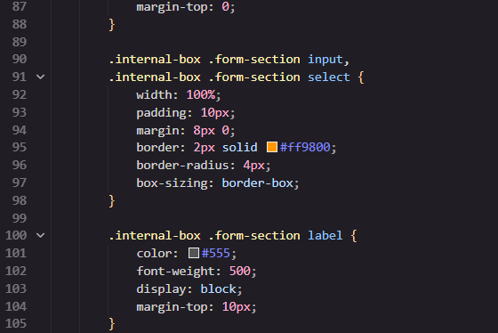
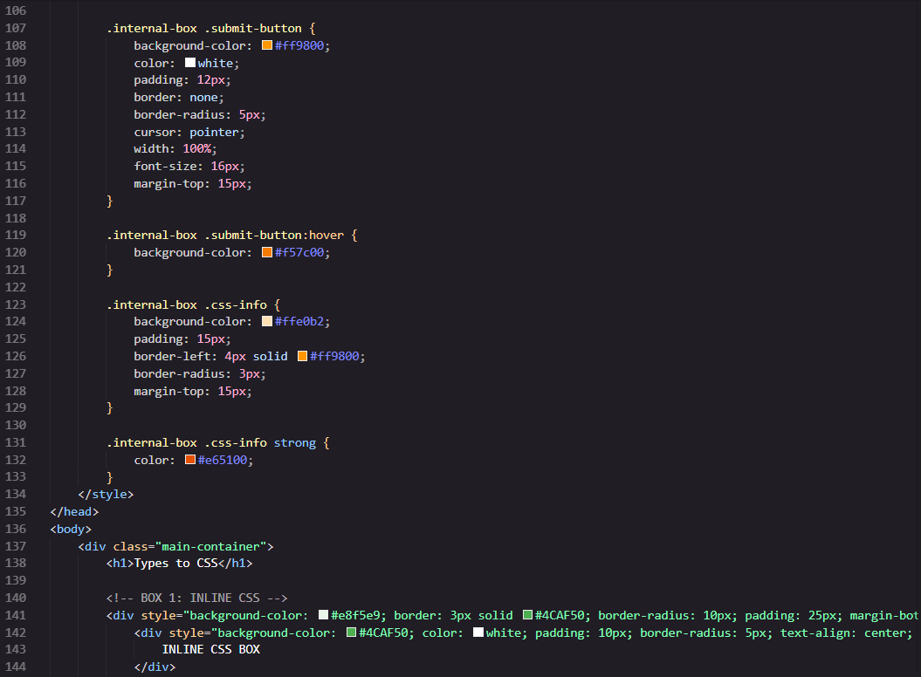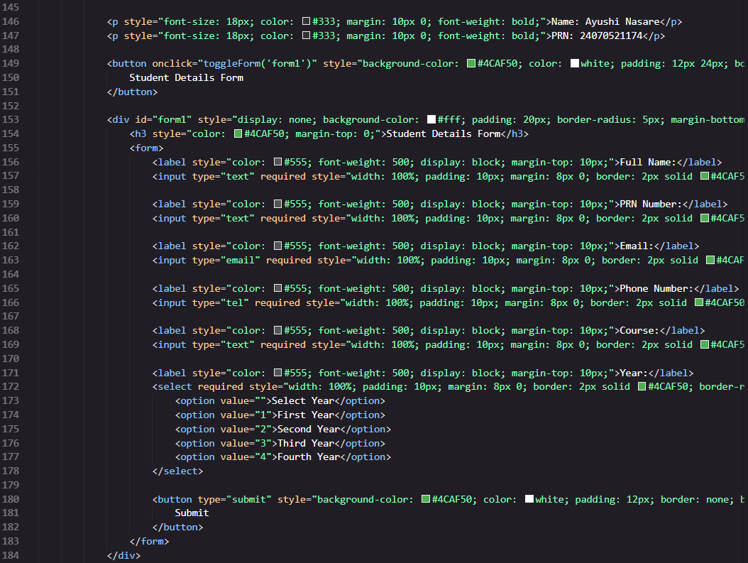
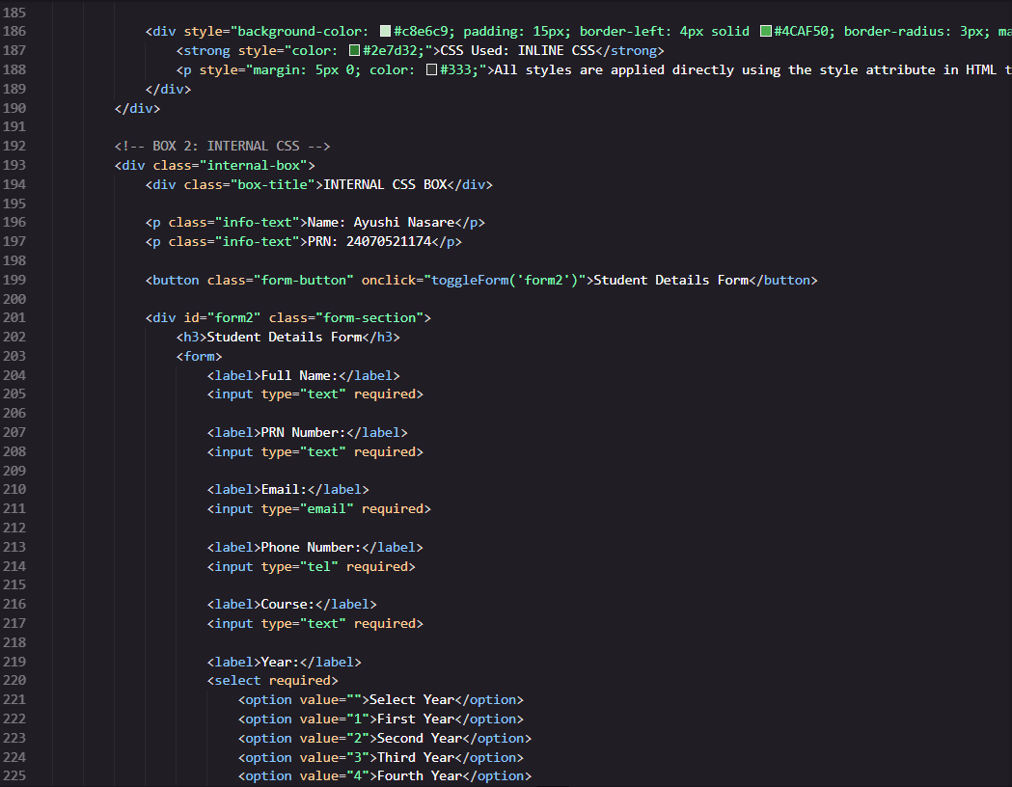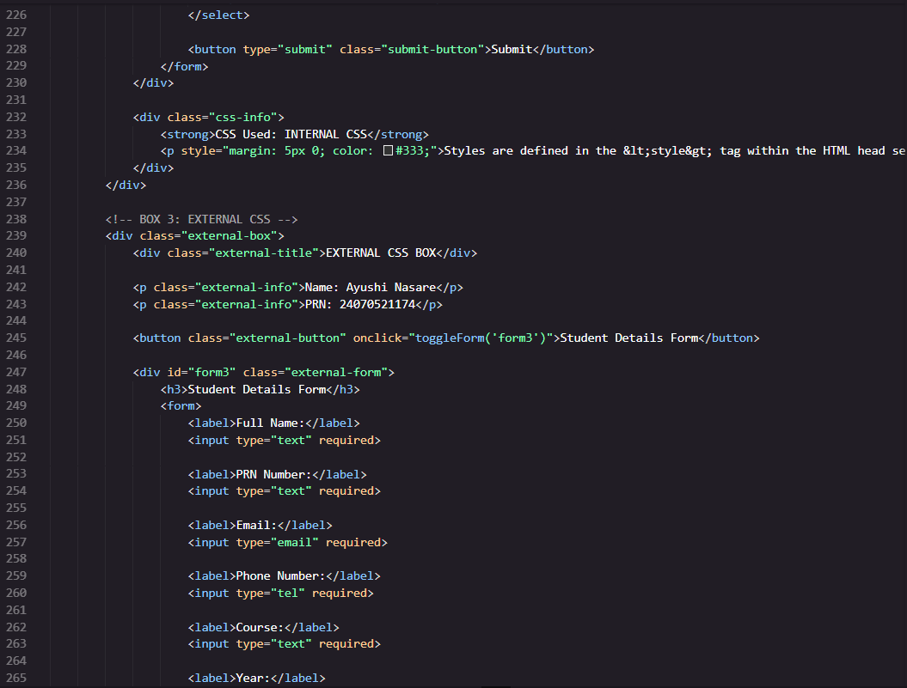
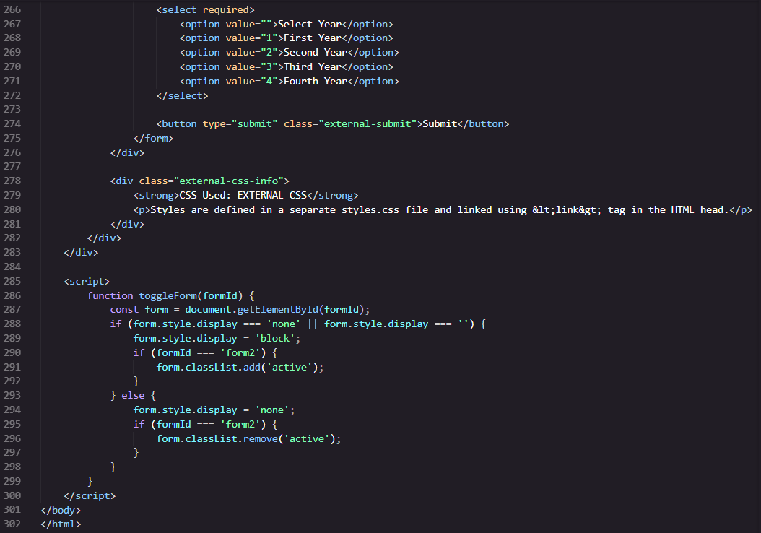
style.css
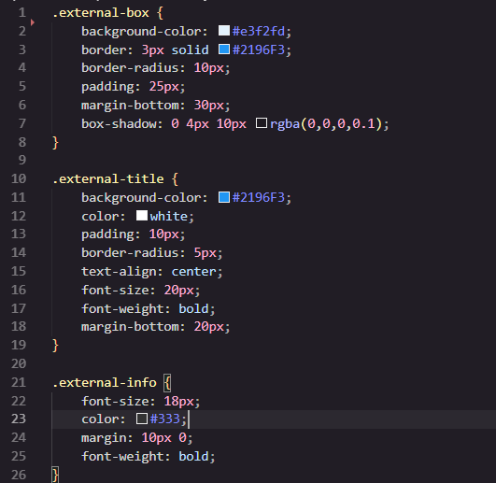
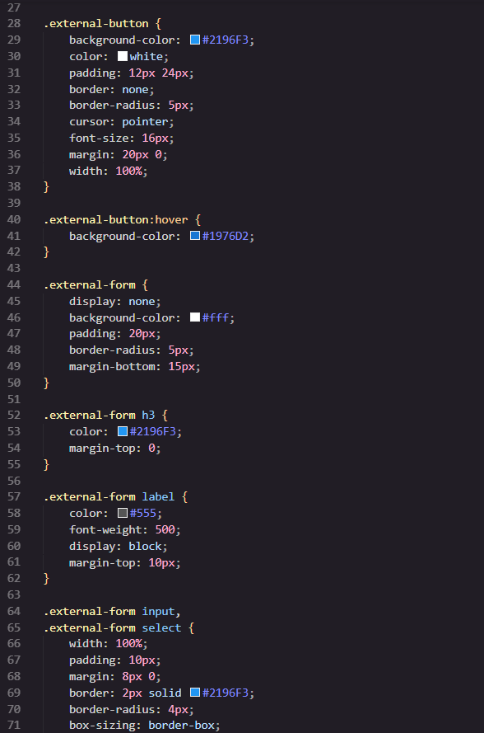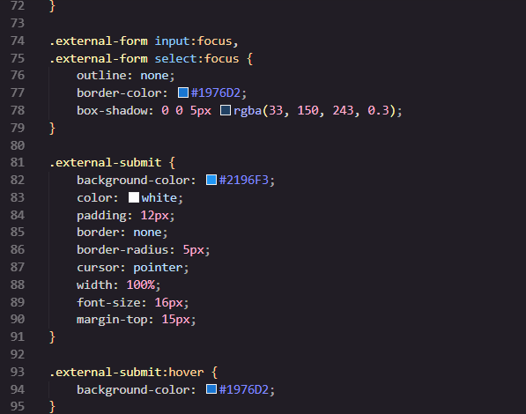

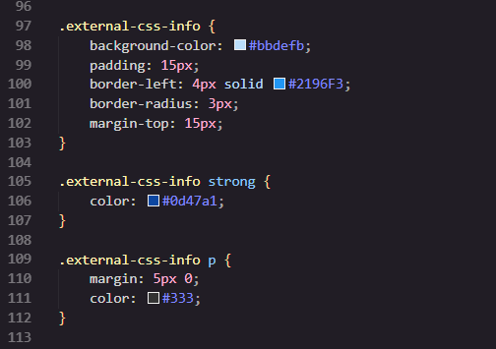
Output:
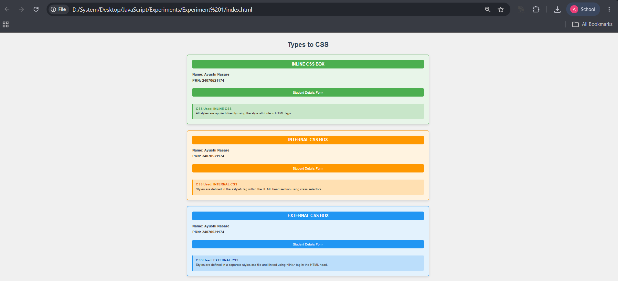

Case Study Title: Create a webpage for college department and link the student information page with it and write a JavaScript program to display”Welcome to SIT Nagpur” in an alter box.
Case Study Program Code:
index.html
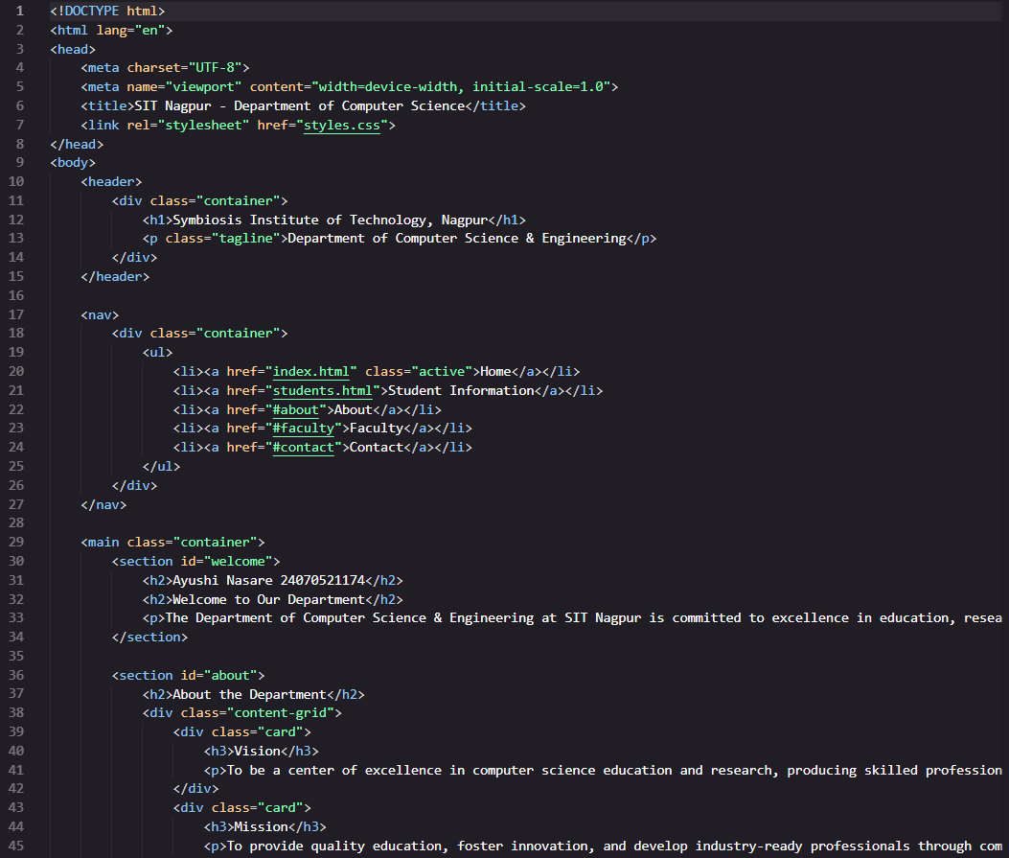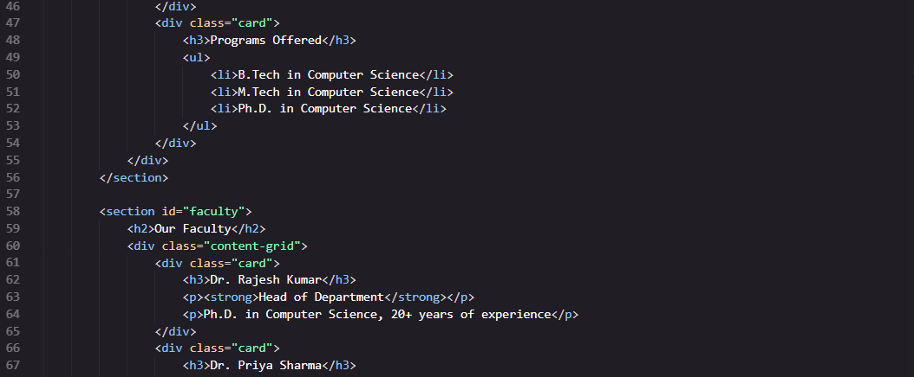

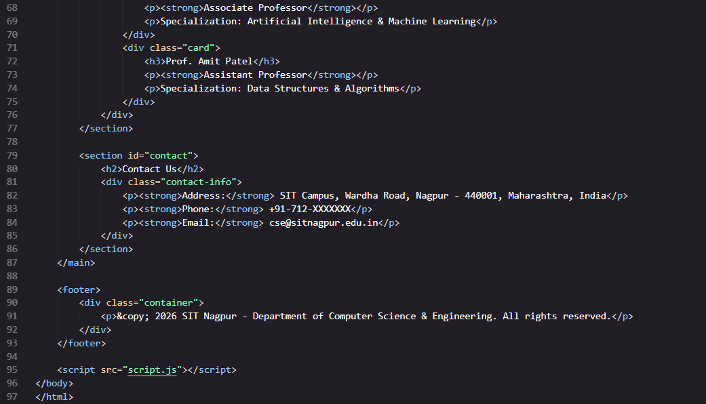
Output: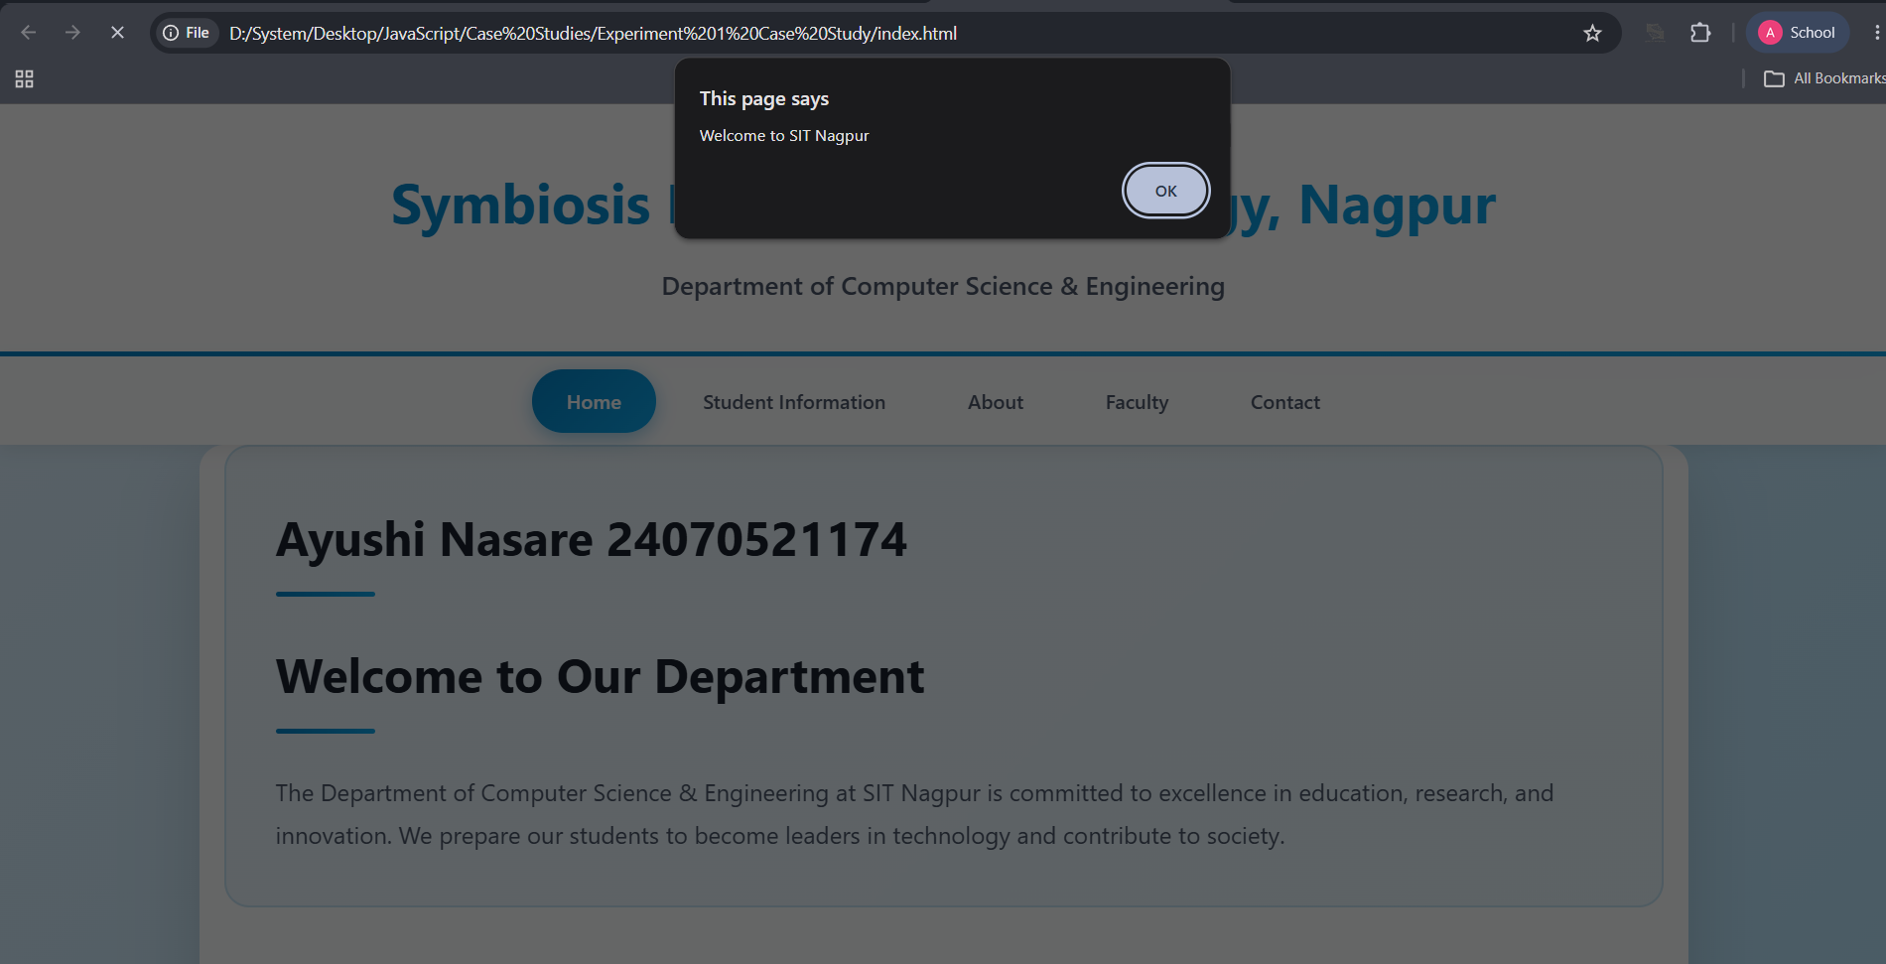 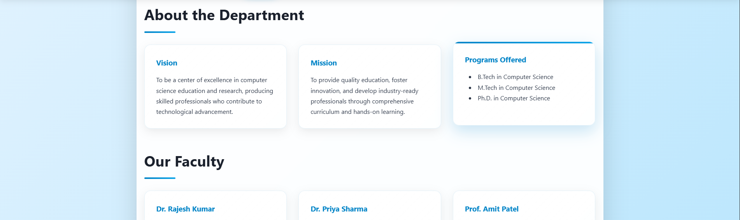
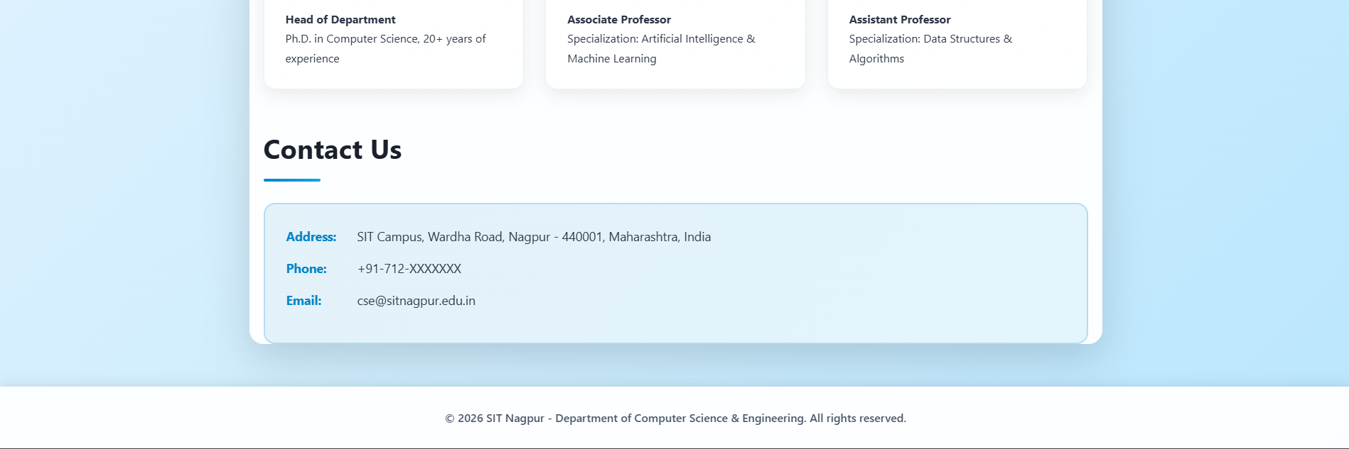
Result/Conclusion:
The experiment was successfully completed. Different ways of adding JavaScript (inline, internal, and external) were implemented and tested. Console methods were used for debugging and displaying information. A webpage was created to display user details along with a welcome message. In the case study, a college department webpage was successfully linked to the student information page, and a JavaScript alert box displayed the message "Welcome to SIT Nagpur" when the webpage was loaded. This experiment helped in understanding the basics of JavaScript integration, webpage navigation, and user interaction using alert messages.

Experiment No. 2
Experiment Title: Use var, let, const, and demonstrate basic features like template literals and destructuring; build a billing calculator with user input.
Software/Tools Required:
- Visual Studio Code (VS Code)
- Google Chrome
- HTML5
- JavaScript
Experiment Program Code:
ayushi_1177.html
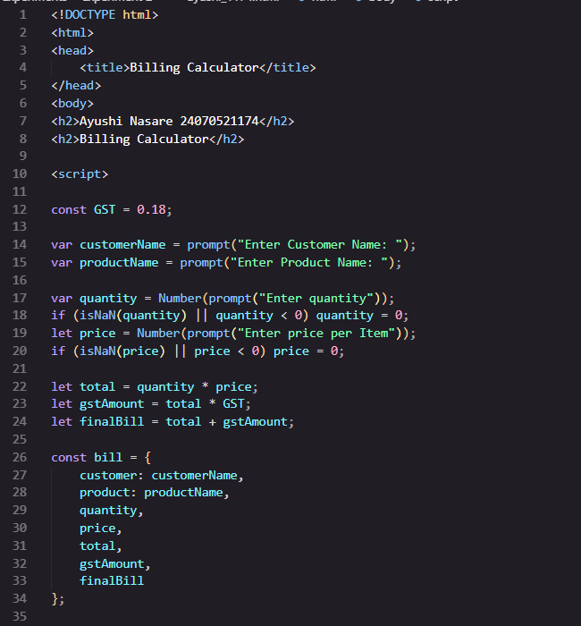
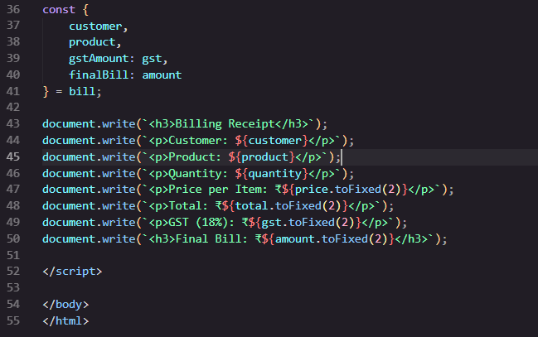
Experiment.html
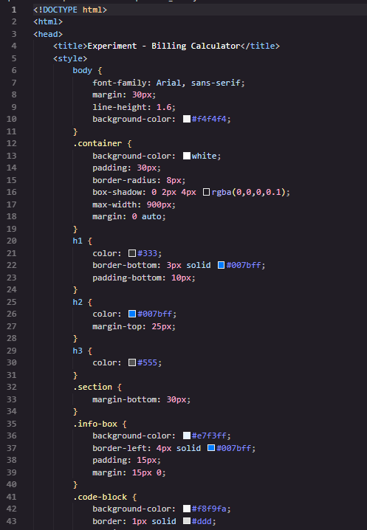
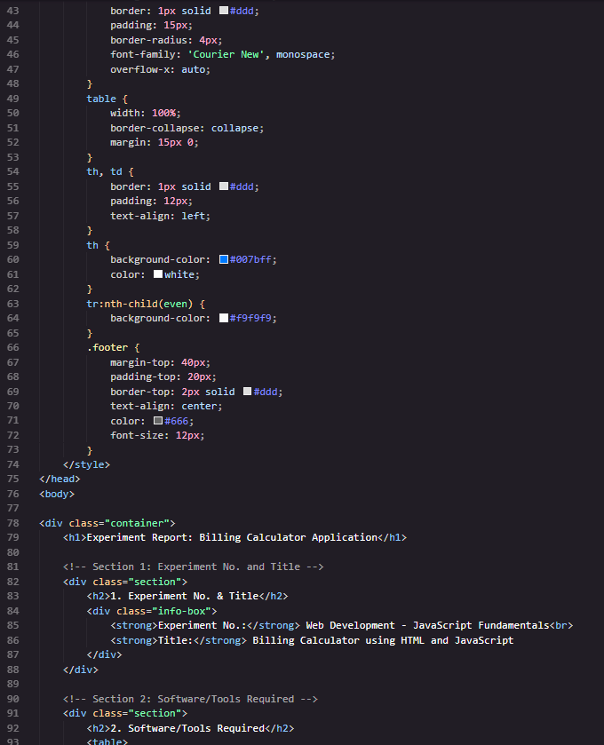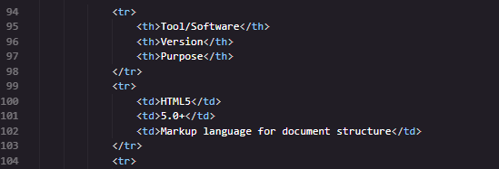
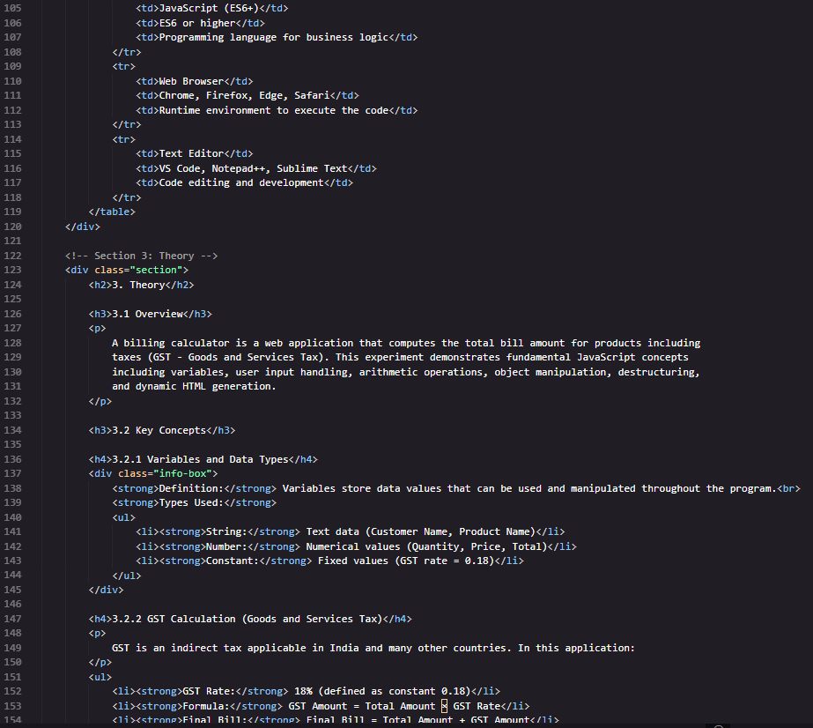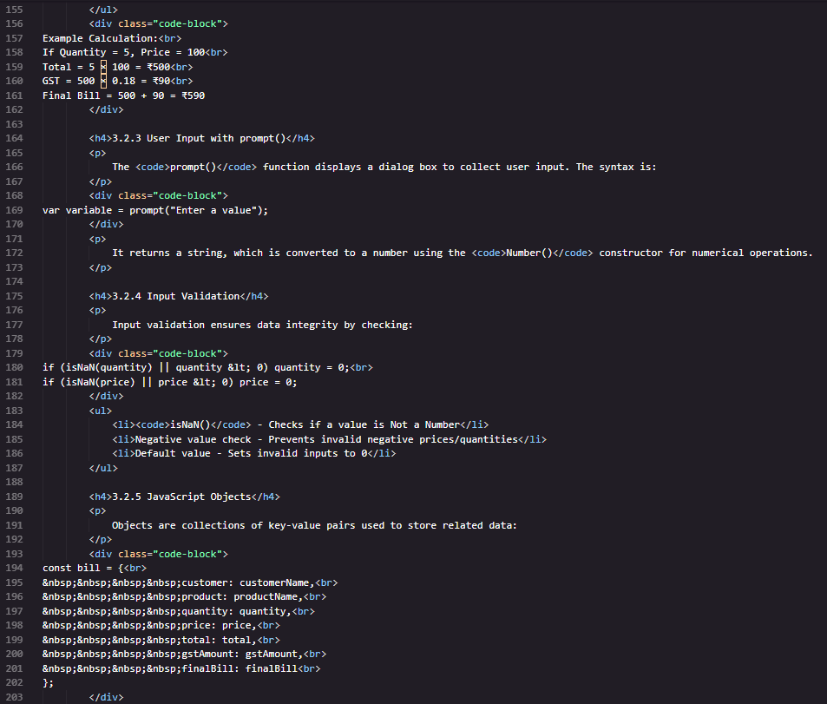
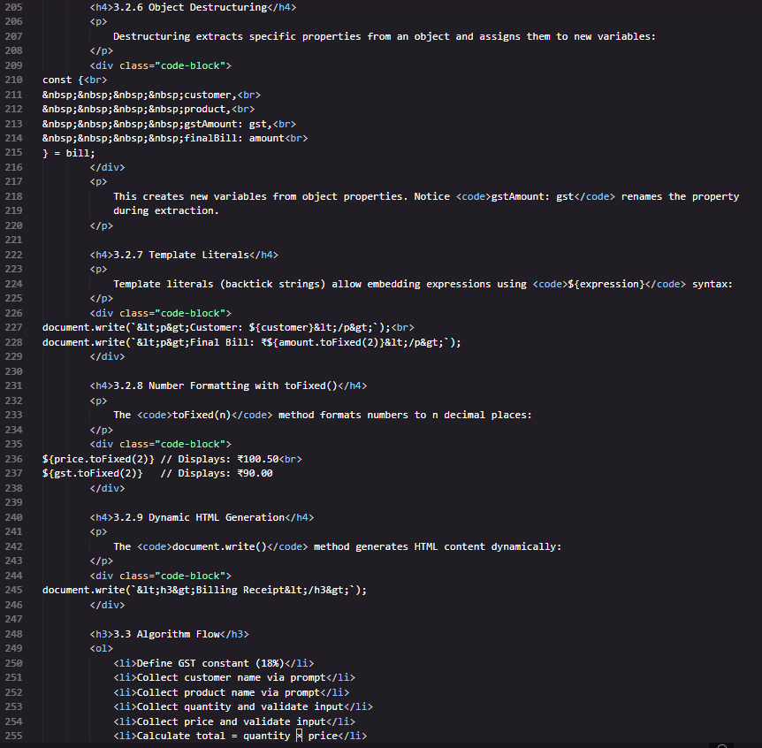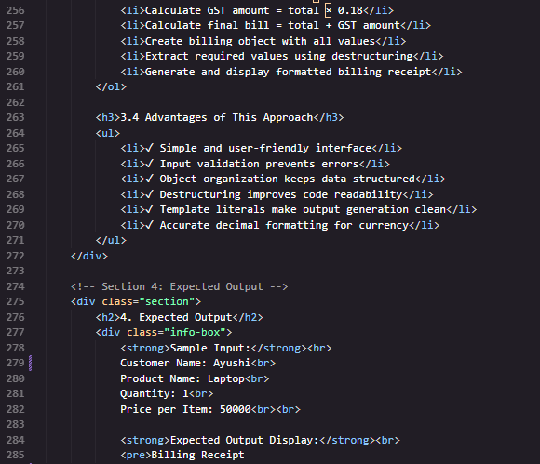
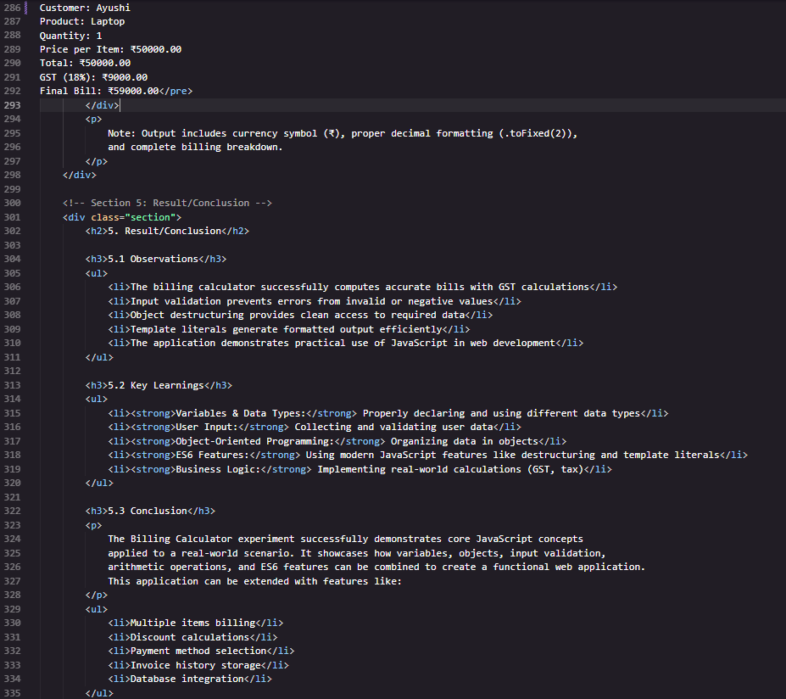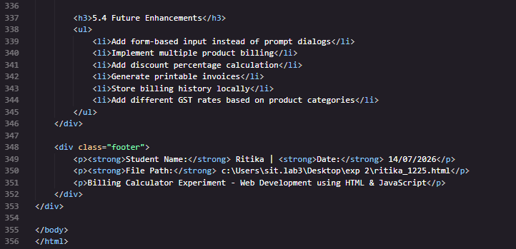
Output:
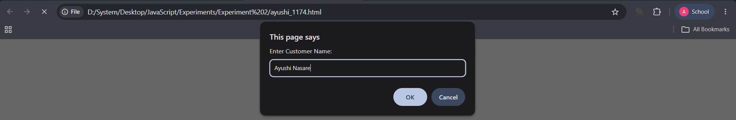

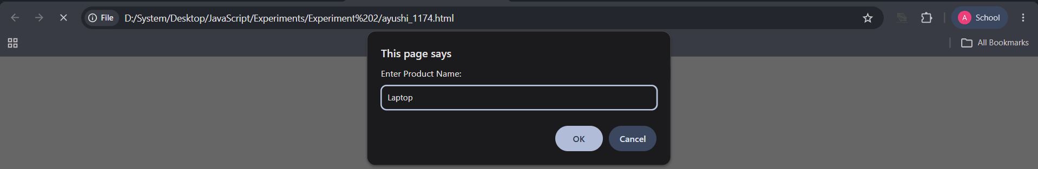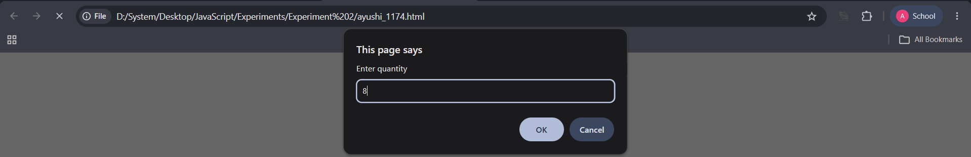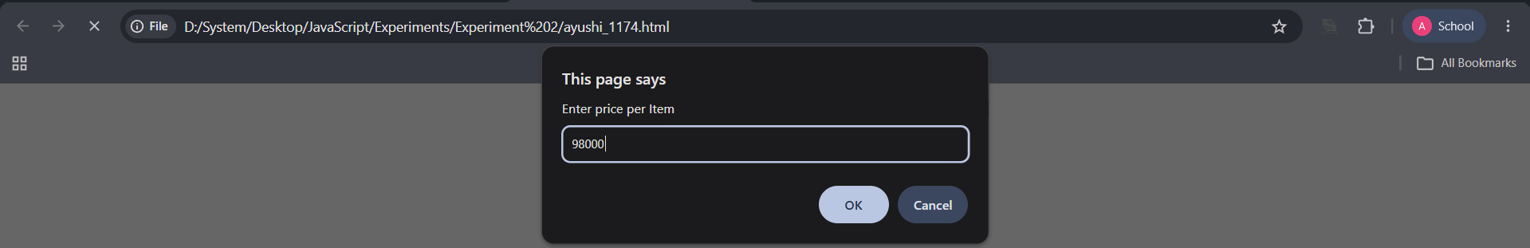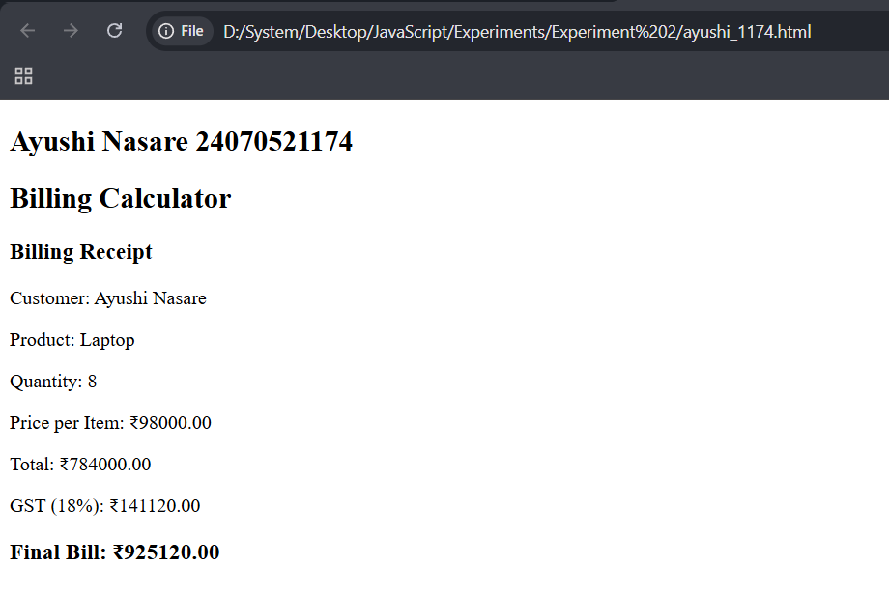

Case Study Title: Develop the webpage for an online shopping website with using HTML, CSS and HTML5 tags and calculate the bill.
Case Study Program Code:
index.html
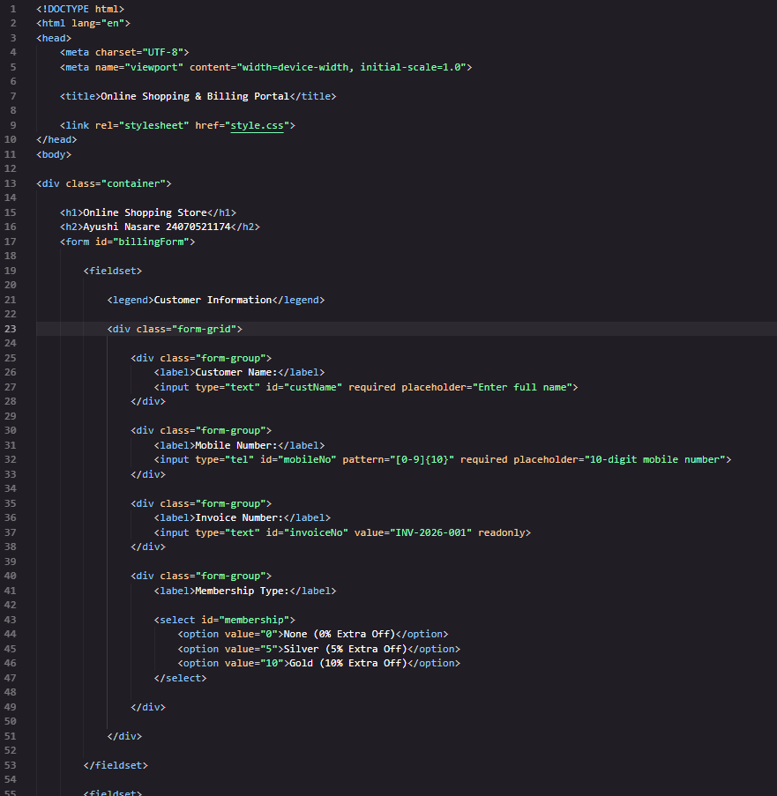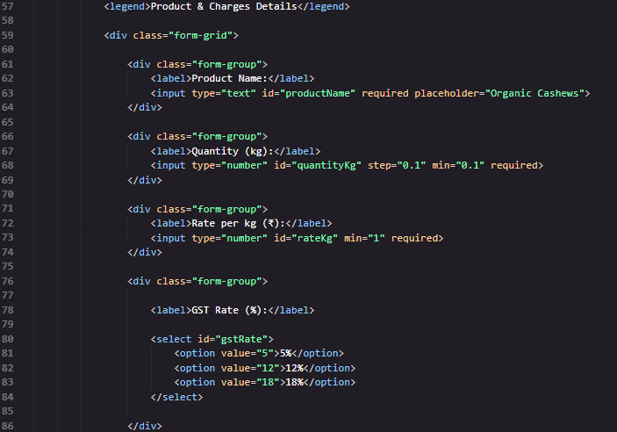
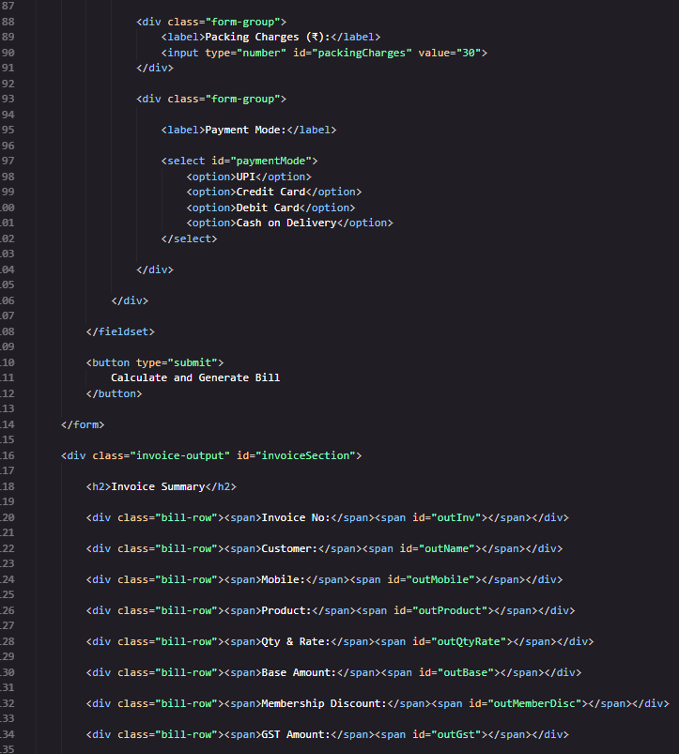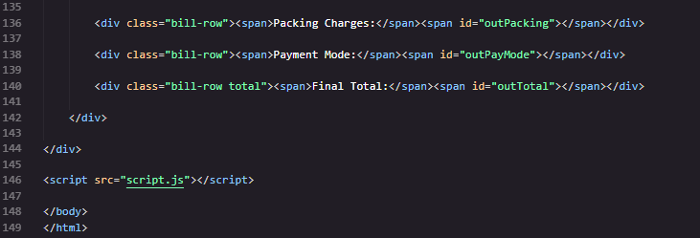

Output:
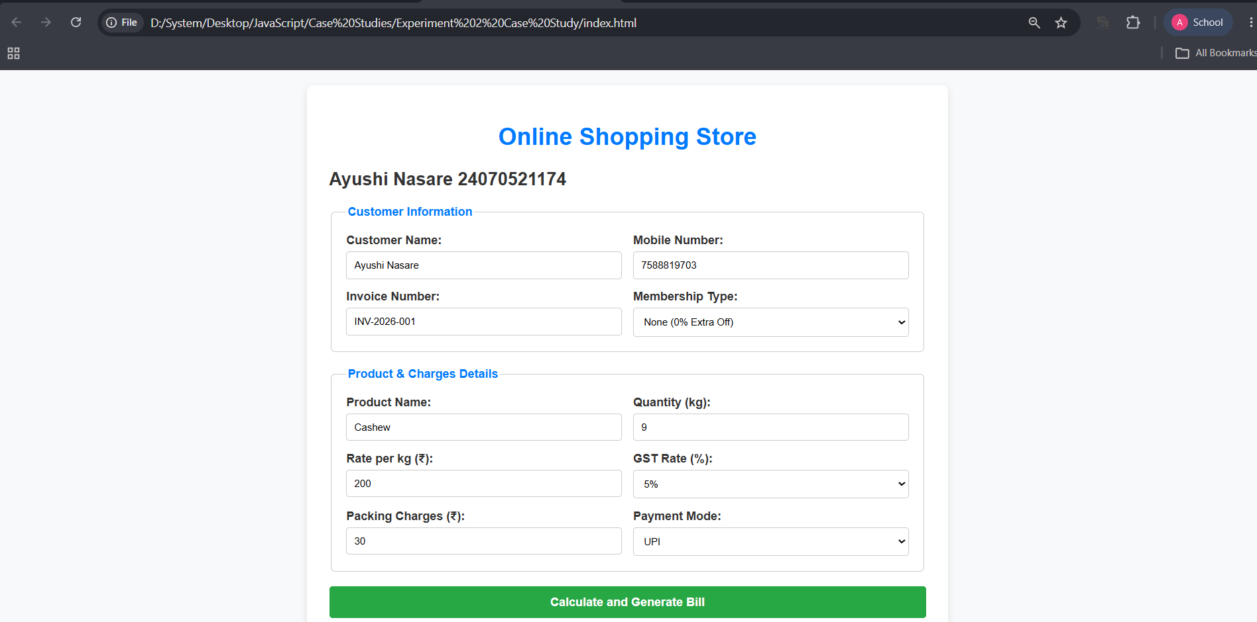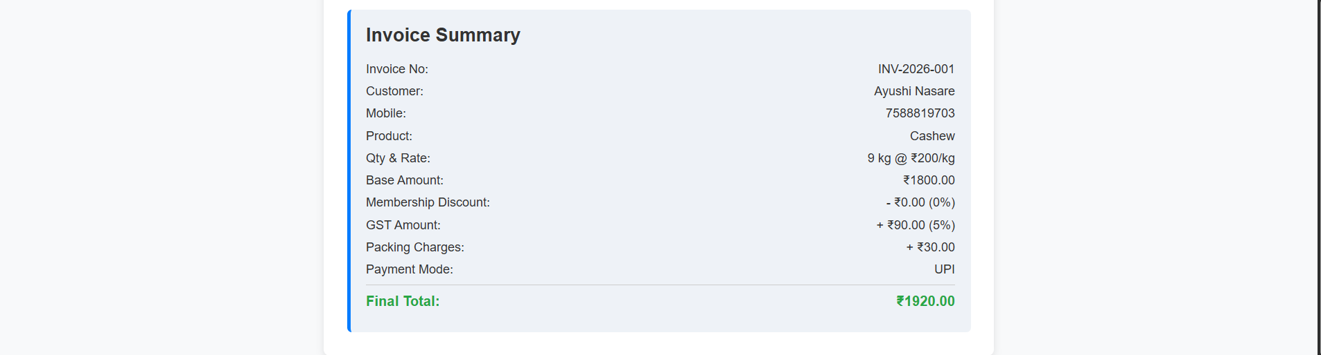
Result/Conclusion:
The experiment was successfully completed. The use of var, let, and const was demonstrated along with modern JavaScript features such as template literals and destructuring. A billing calculator was developed to accept user input, calculate the total bill, and display the result accurately. In the case study, an online shopping webpage was created using HTML, CSS, and HTML5 tags, and JavaScript was used to calculate the final bill based on the selected products. This experiment improved the understanding of JavaScript variables, ES6 features, user input handling, and dynamic bill calculation in web applications.

Experiment No. 3
Experiment Title: Implement control structures and form validation; create a grading system based on user-entered marks.
Software/Tools Required:
- Visual Studio Code (VS Code)
- Google Chrome
- HTML5
- JavaScript
Experiment Program Code:
index.html
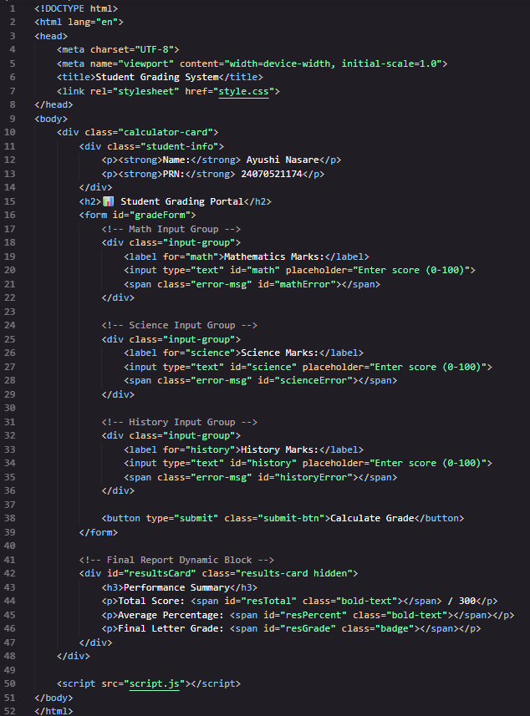
style.css
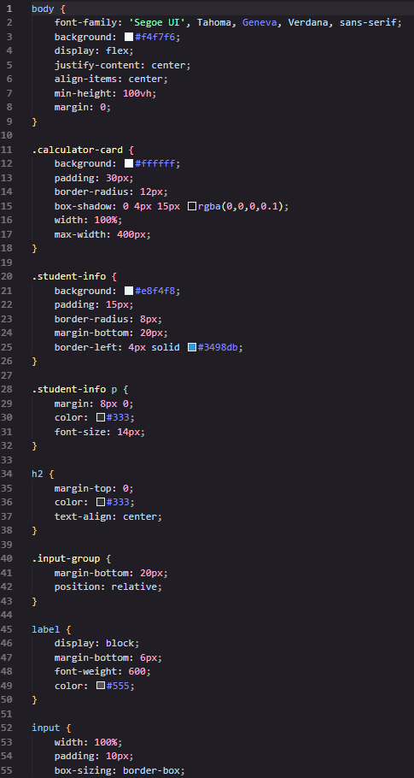

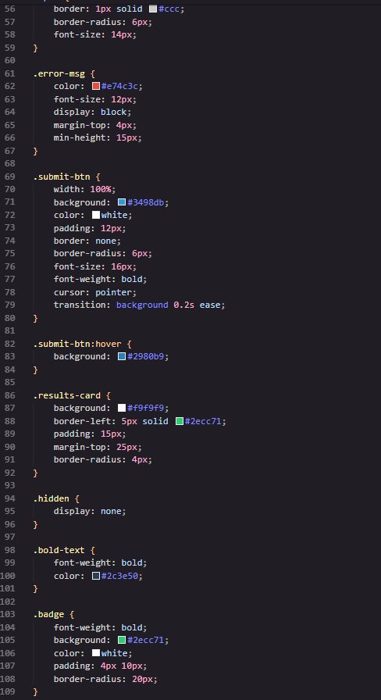

script.js
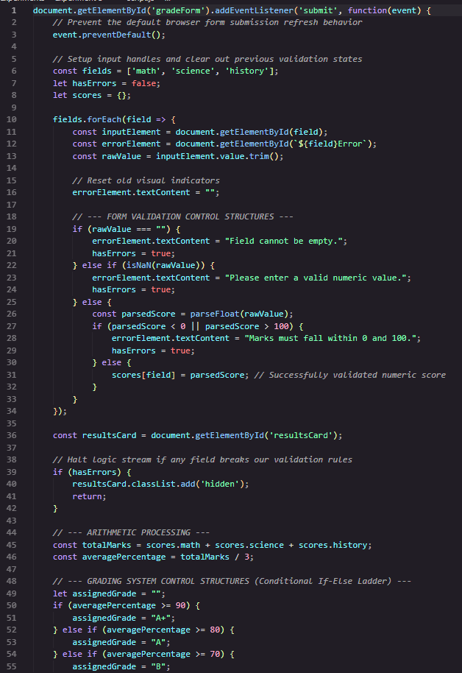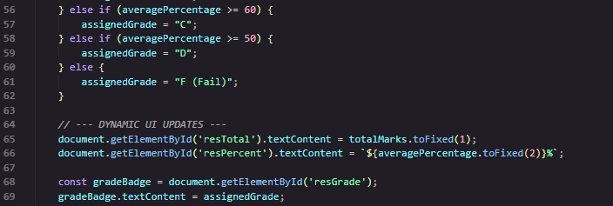
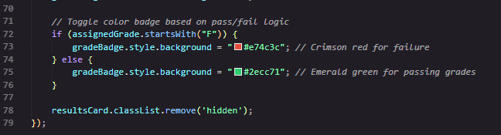
Output:
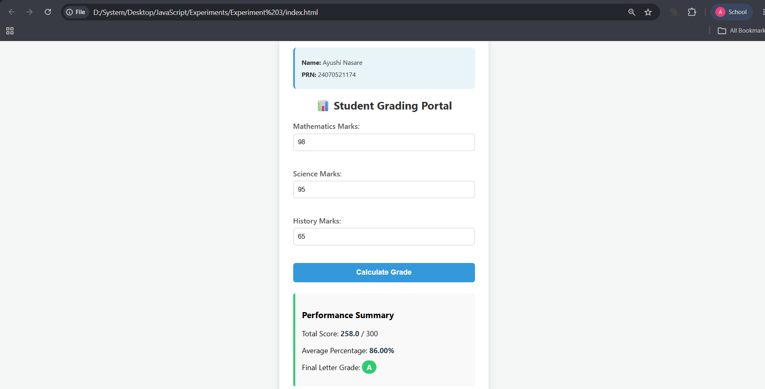

Case Study Title: WAP to output Grade “C” if entered marks are between 50-65, “B” for 66-80 and “A” for 80-90 and “A+” for above 90.
Case Study Program Code:
index.html
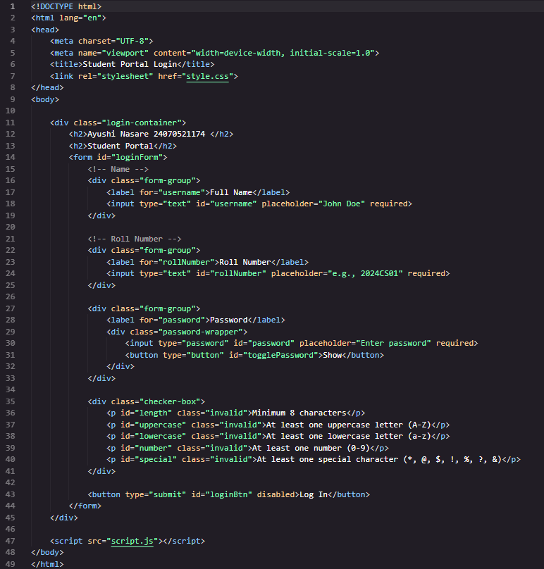
style.css
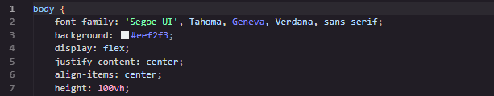
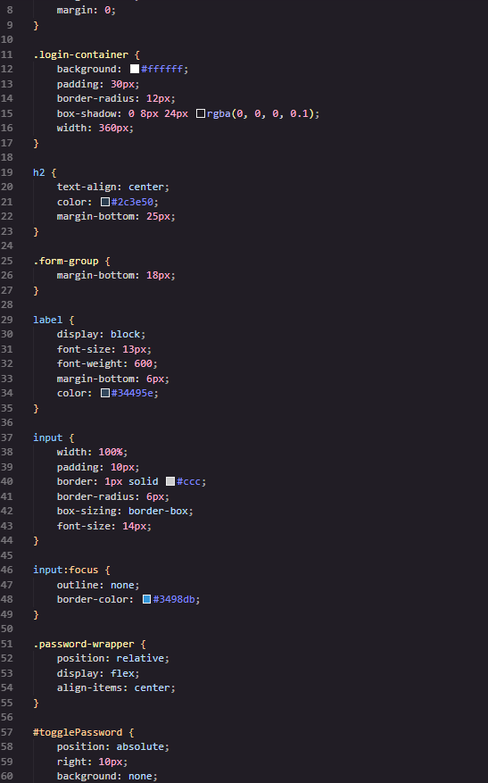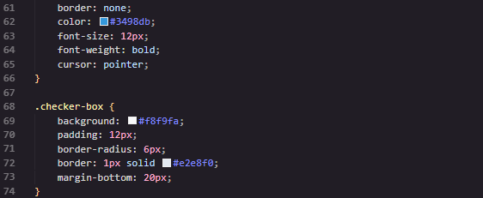
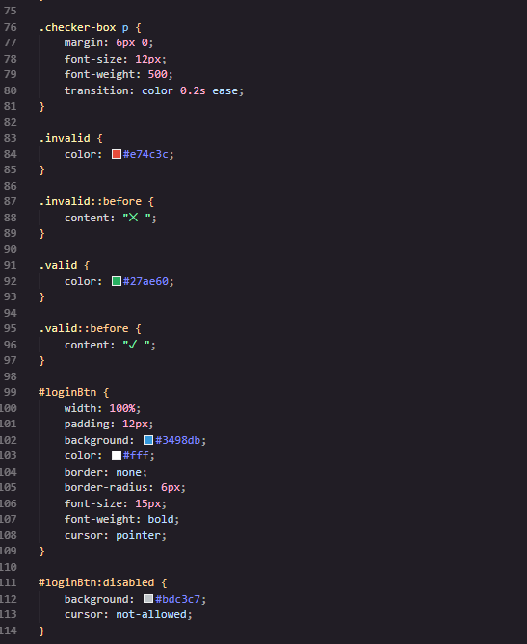
script.js
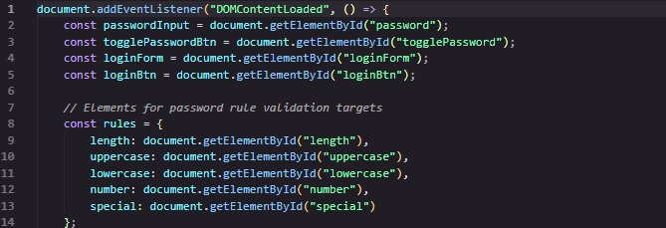
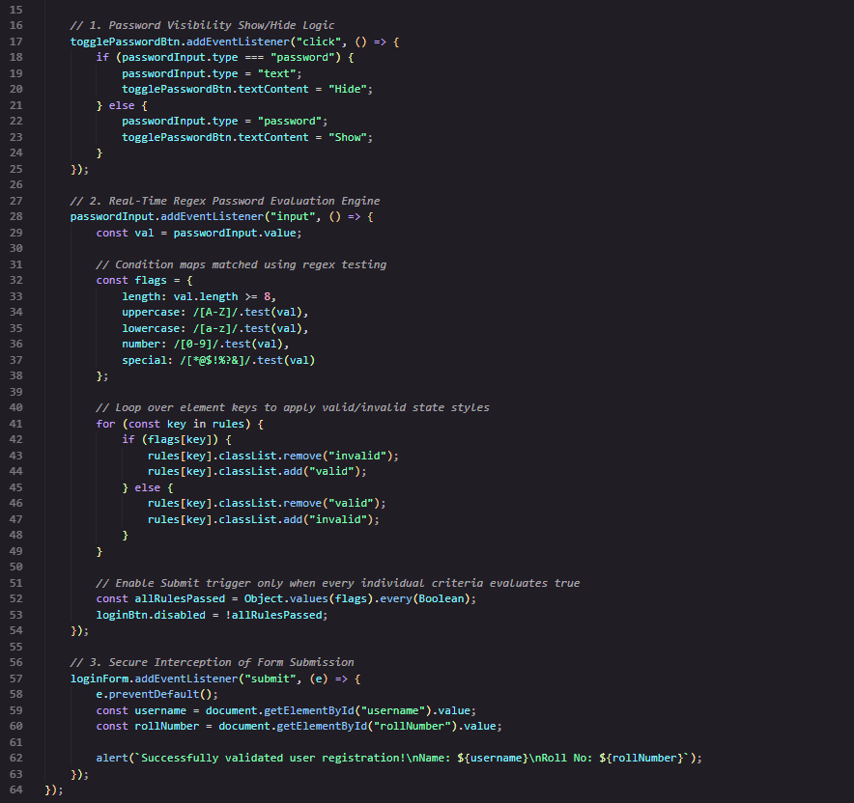
Output:
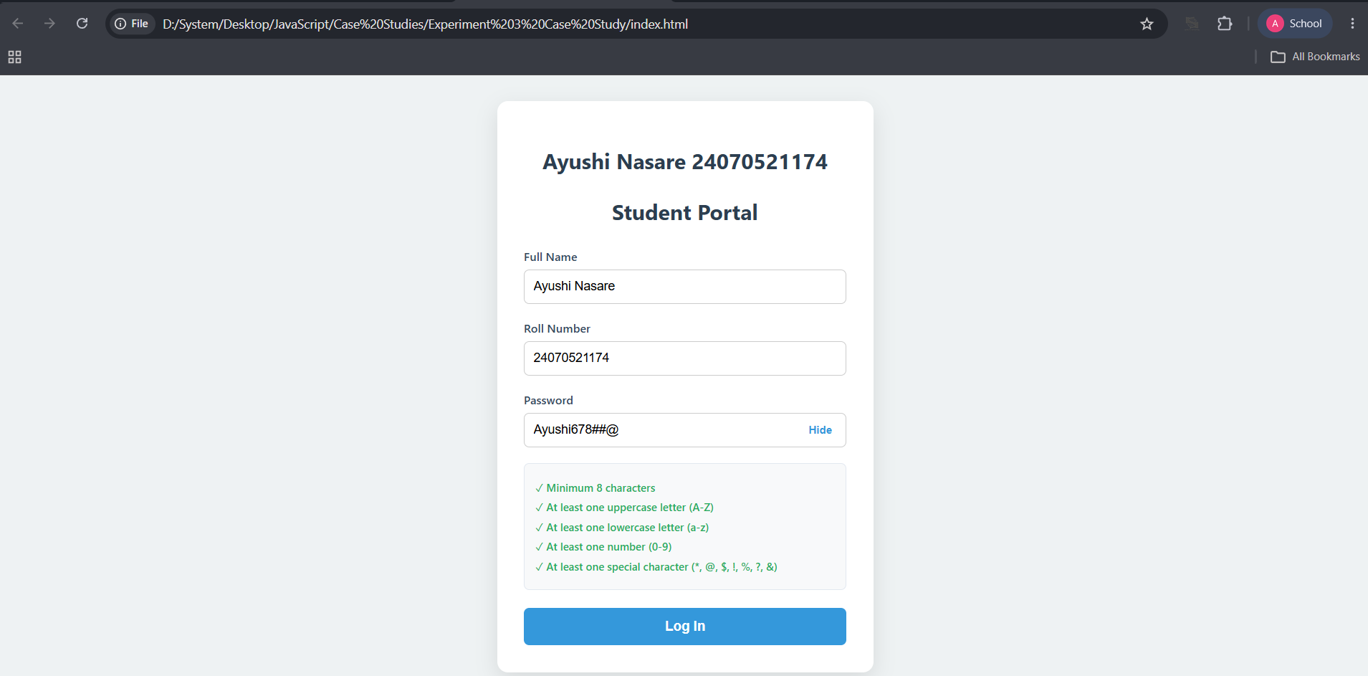
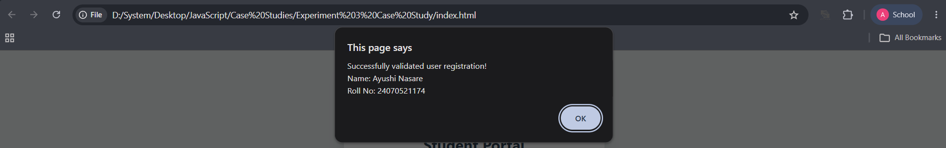
Result/Conclusion: The grading system was successfully implemented using JavaScript control structures and form validation, accurately assigning grades based on the marks entered by the user.
Experiment No. 4
Experiment Title: Use function types, scope, and closures; apply try-catch; build a palindrome checker.
Software/Tools Required:
- Visual Studio Code (VS Code)
- Google Chrome
- HTML5
- JavaScript
Experiment Program Code:
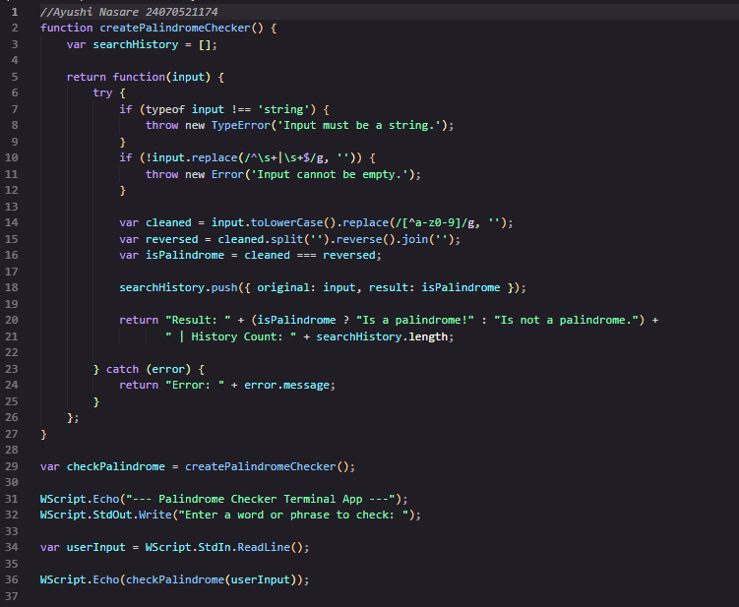
Output:
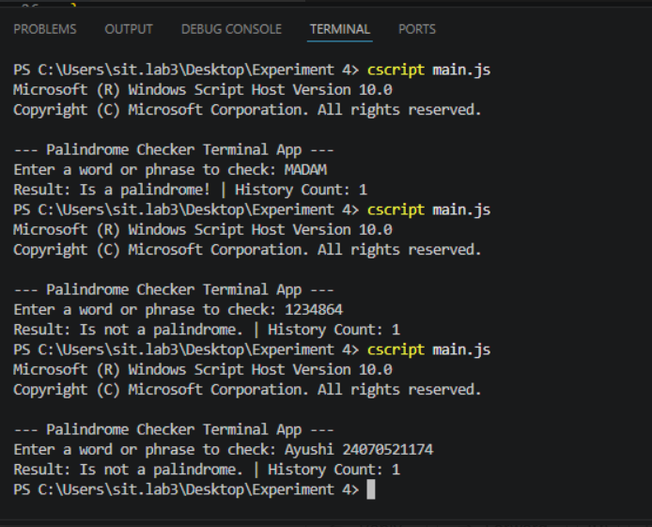
Case Study Title: An ATM system verifies whether a customer PIN is palindrome. If the PIN reads the same forward and backward the bank displays special security message. To implement this, create a function to reverse and the entered PIN number and another function to check whether it is palindrome. Use function declaration, function expression, arrow function and demonstrate scope concepts.
Case Study Program Code:
index.html
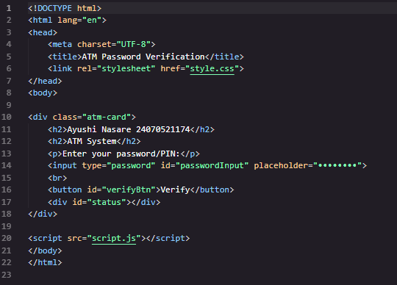
style.css
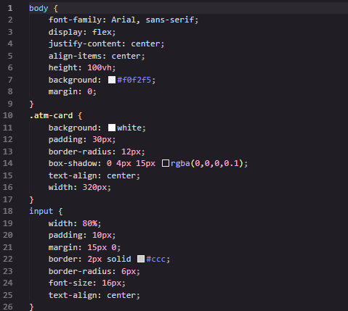
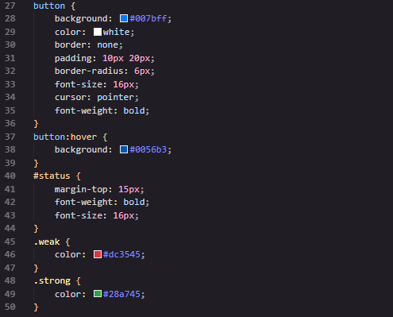
script.js
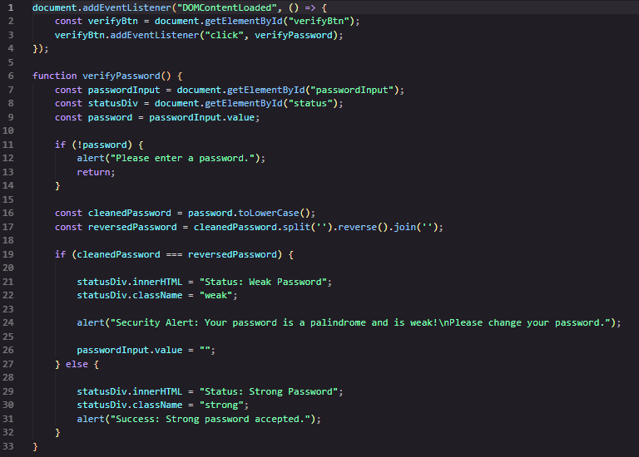

Output:
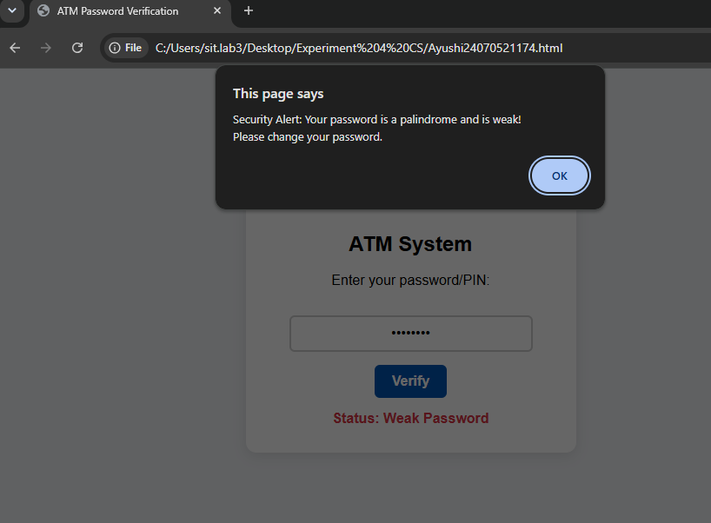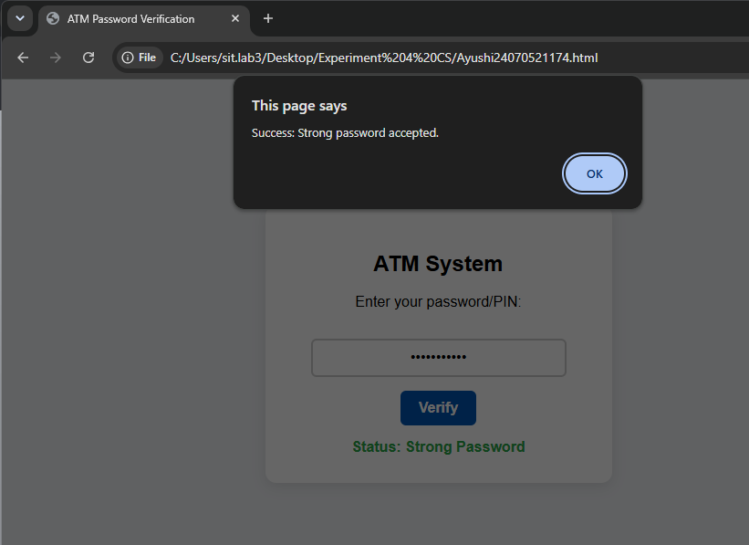
Result/Conclusion:
The experiment was successfully completed. Different types of JavaScript functions, scope, closures, and try-catch were implemented. A palindrome checker and an ATM PIN palindrome verification system were developed successfully. This experiment improved the understanding of JavaScript functions, error handling, and modular programming.

Experiment No. 5
Experiment Title: Apply array methods and object handling; create a cart total calculator with discount logic.
Software/Tools Required:
- Visual Studio Code (VS Code)
- Google Chrome
- HTML5
- JavaScript
Experiment Program Code:
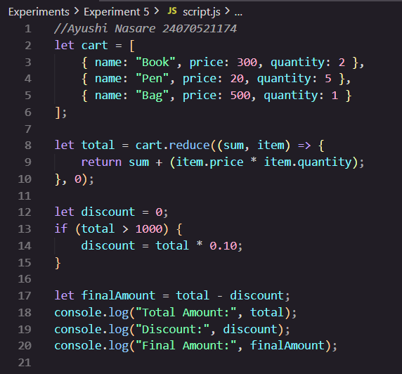
Output:
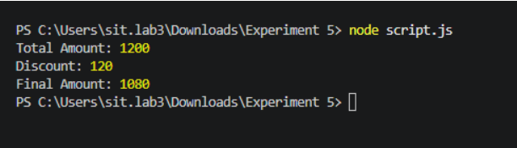

Case Study Title: To study the functioning of Array and Loops in JavaScript
- Create and manipulate array: push, pop, shift, unshift, splice, slice
- Use array methods: map(), filter(), reduce(), forEach()
Create an array of numbers and find the maximum and minimum value.
Case Study Program Code:
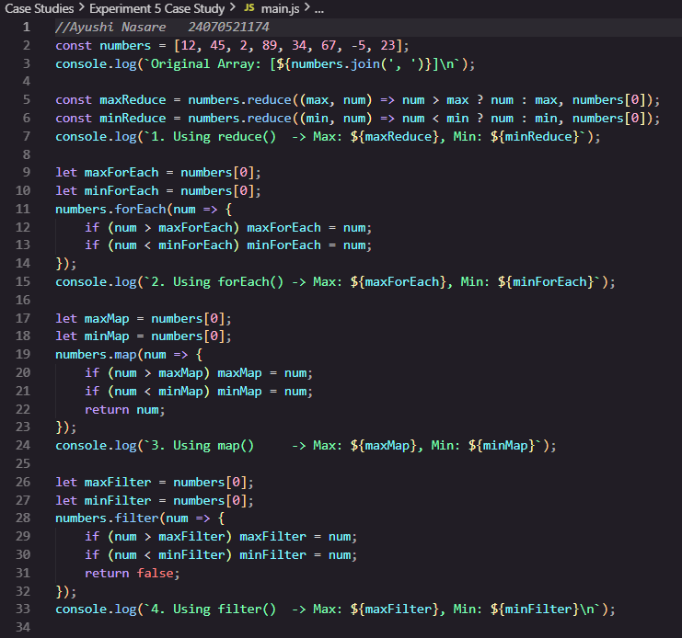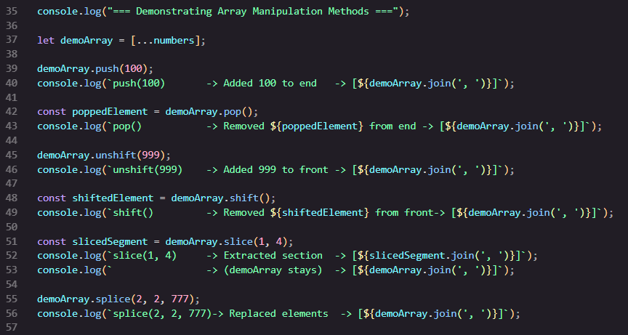
Output:
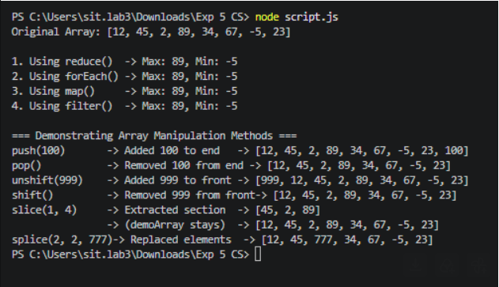
Result/Conclusion:
The discount based on the defined spending threshold using array methods reduce(), find(), map() it successfully updates the user interface in real time providing an interactive shopping cart experience in INR

Experiment No. 6
Experiment Title: User string functions and regex for email validation, data extraction and text analysis.
Software/Tools Required:
- Visual Studio Code (VS Code)
- Google Chrome
- HTML5
- JavaScript
Experiment Program Code:
index.html
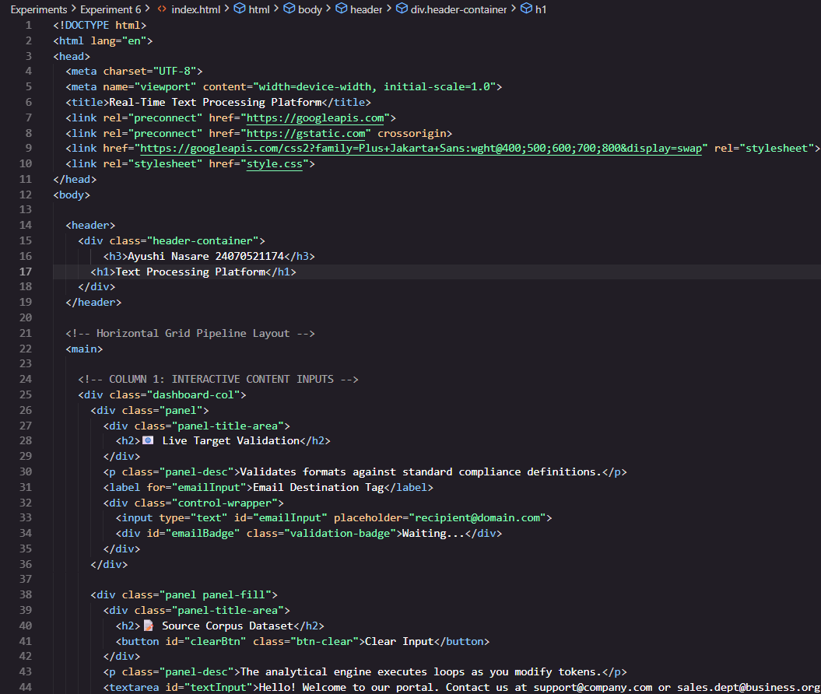
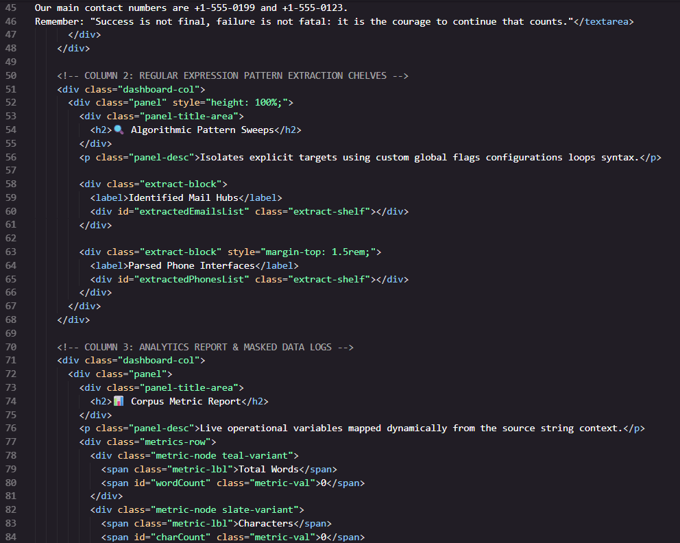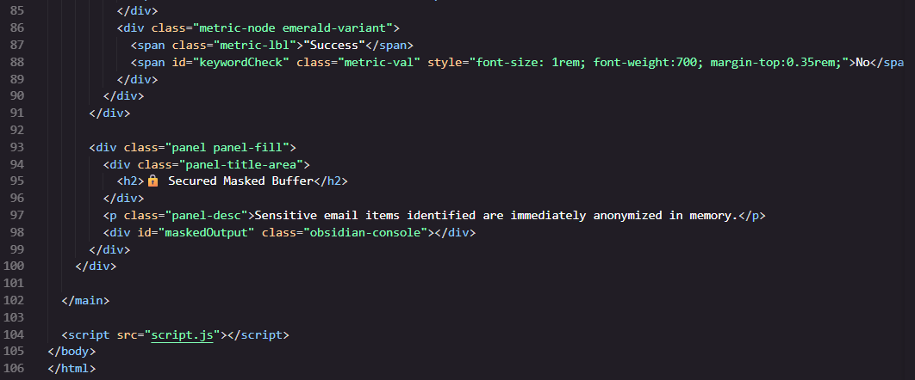
Output:
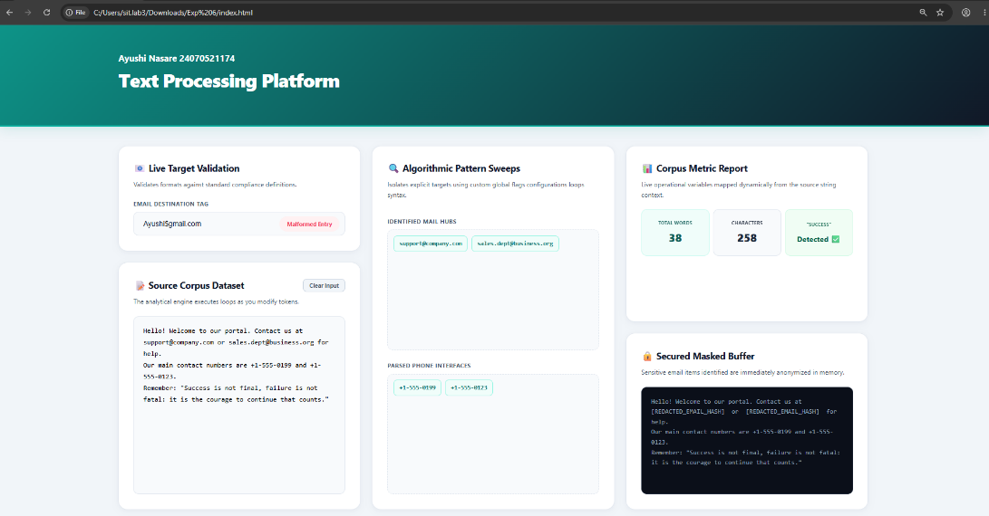
Case Study Title: To perform various String operations using JavaScript.
- To perform basics of String.
- Work with strings: substring(), indexOf(), split(), replace()
- Write a program to reverse a string.
- WAP to count number of vowels in a paragraph

Case Study Program Code:
StringOperations.js
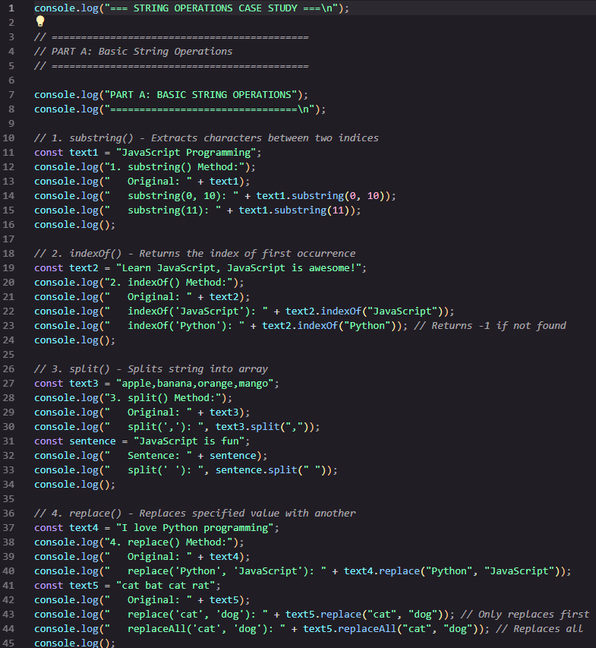
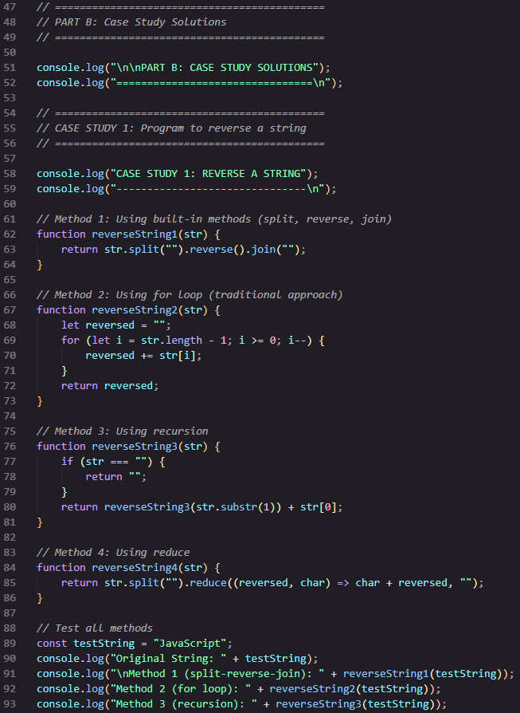
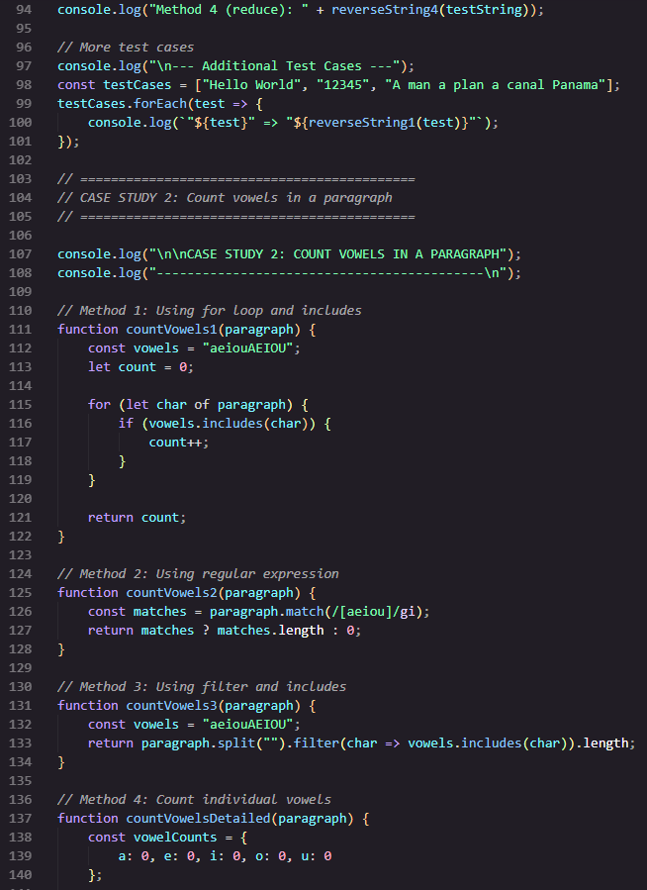
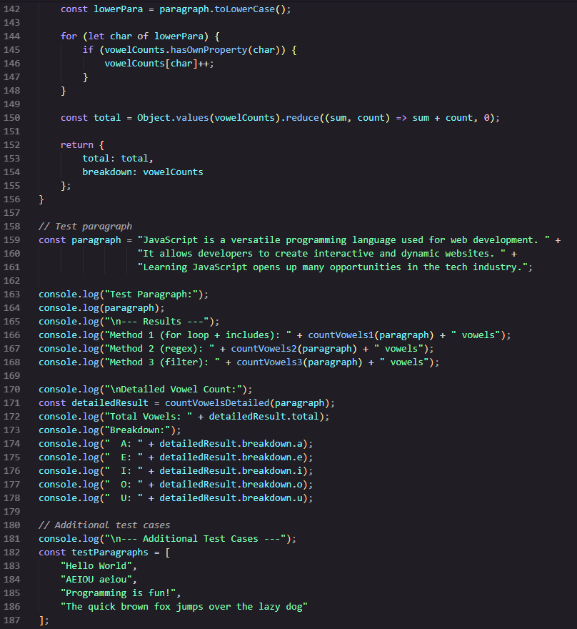
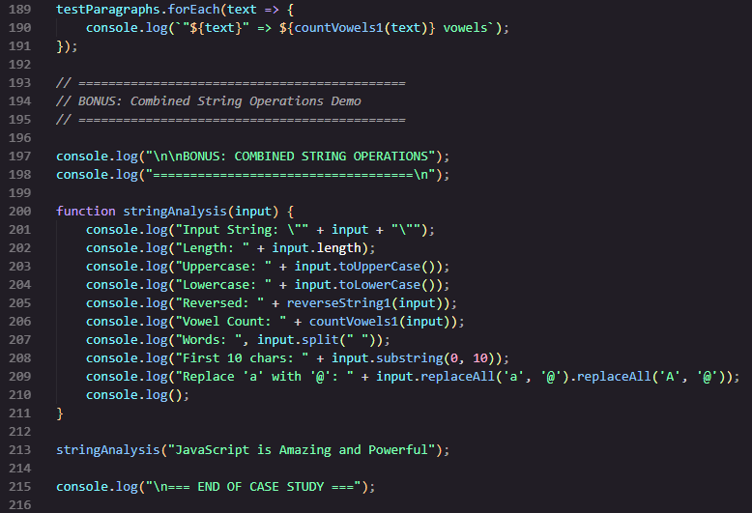
Output:
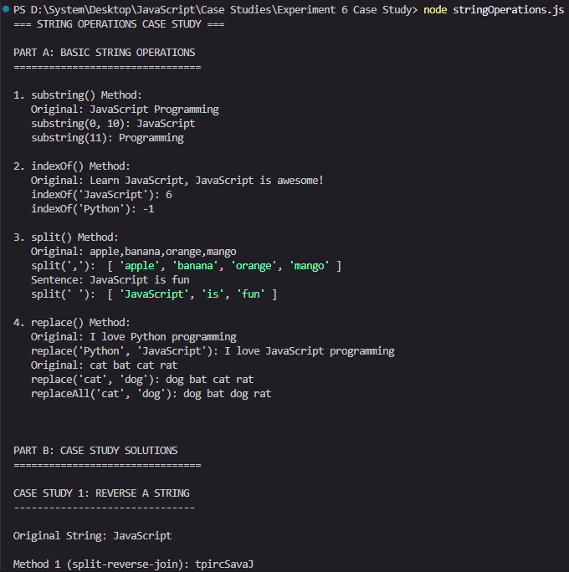
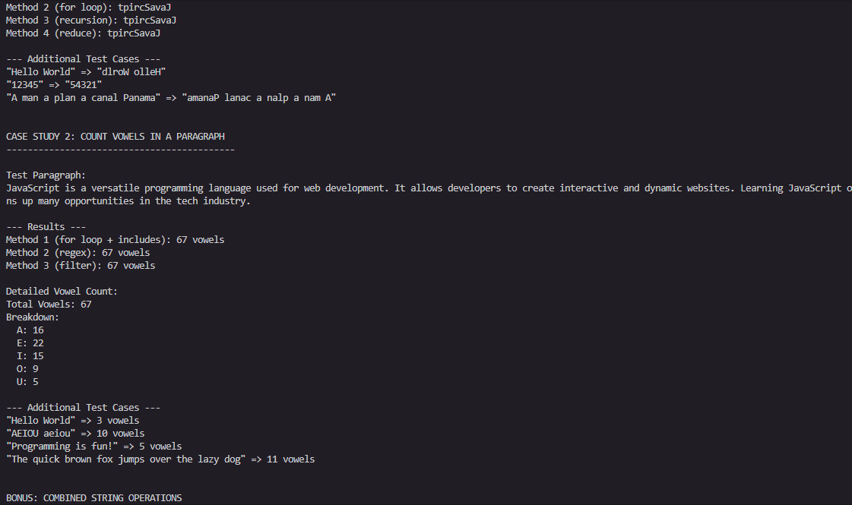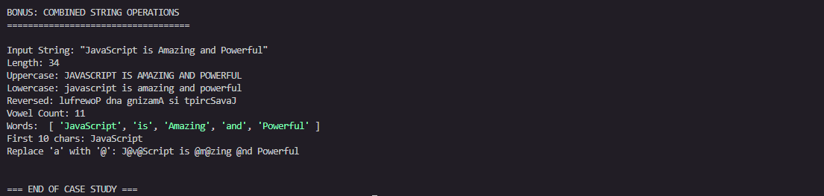
Result/Conclusion:
The various String operations in JavaScript were successfully performed. Basic string operations along with substring(), indexOf(), split(), and replace() methods were implemented. Programs to reverse a string and count the number of vowels in a paragraph were also executed successfully, producing the expected results.
Thus, the practical demonstrated the use of JavaScript string handling and manipulation methods. It helped in understanding how strings can be accessed, searched, divided, modified, reversed, and analyzed using JavaScript.

Experiment No. 7
Experiment Title: Perform DOM traversal and updates; develop to-do list app with add, edit, and delete features.
Software/Tools Required:
- Visual Studio Code (VS Code)
- Google Chrome
- HTML5
- JavaScript
Experiment Program Code:
index.html
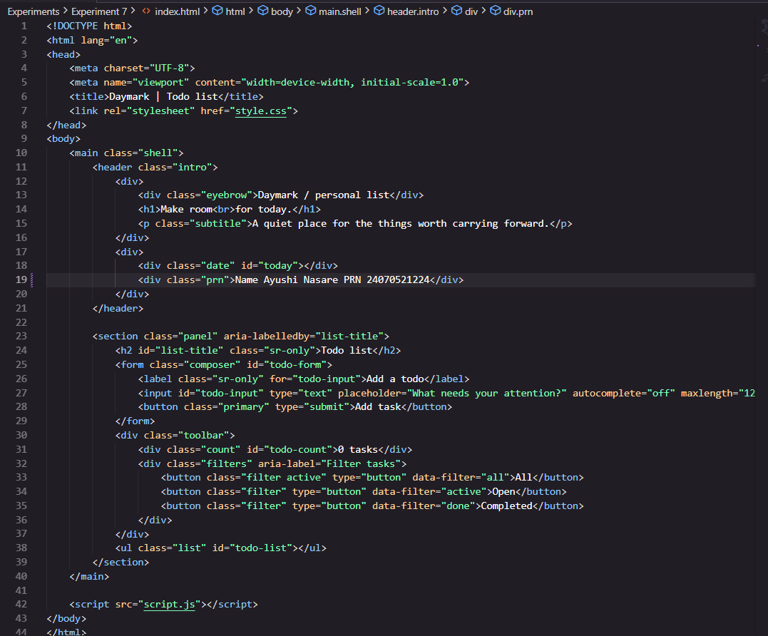

script.js
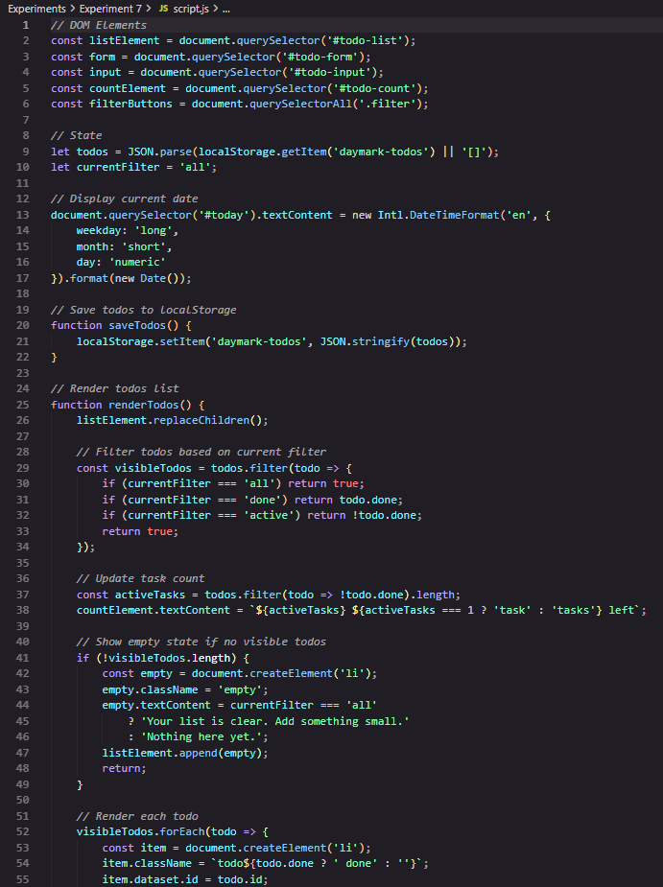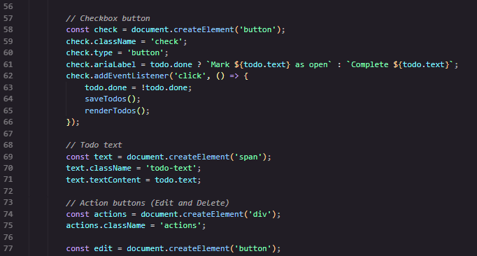

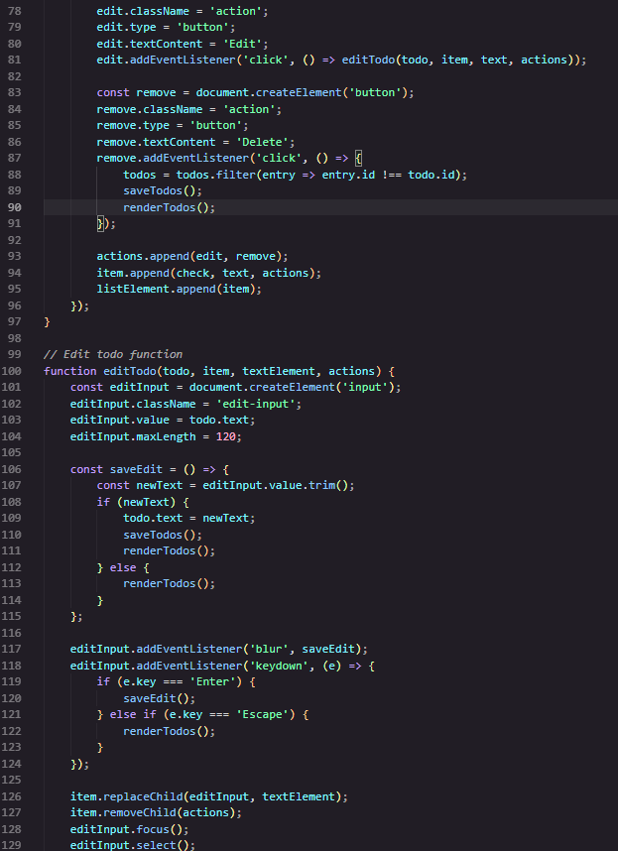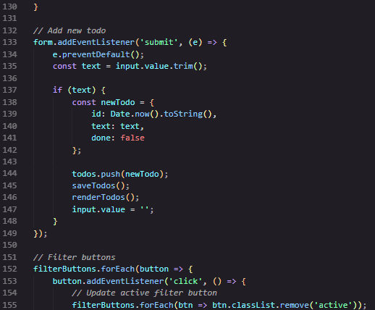

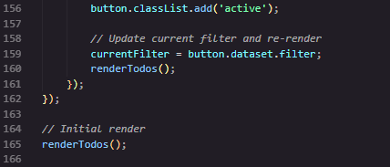
style.css
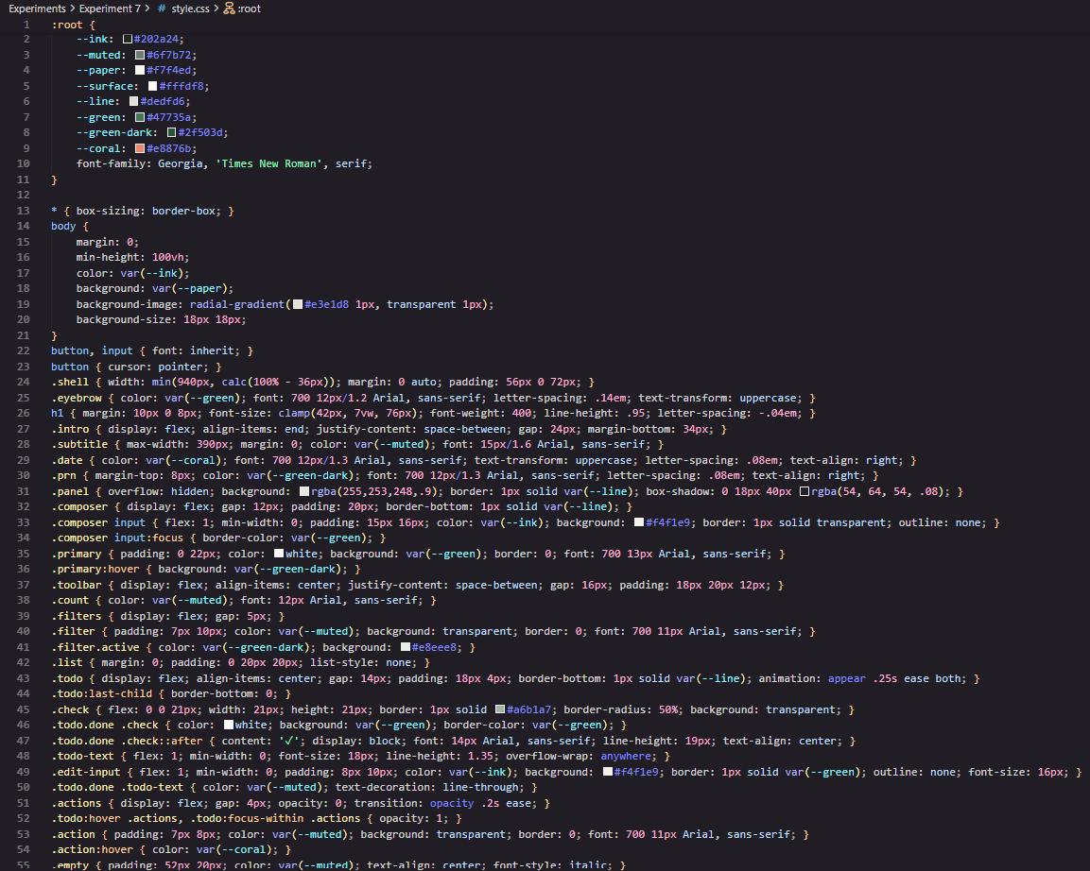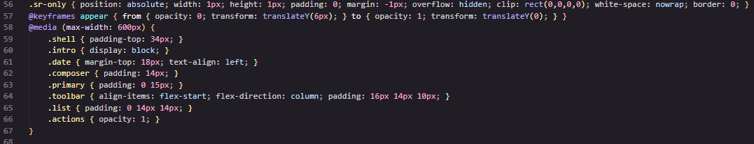

Output:
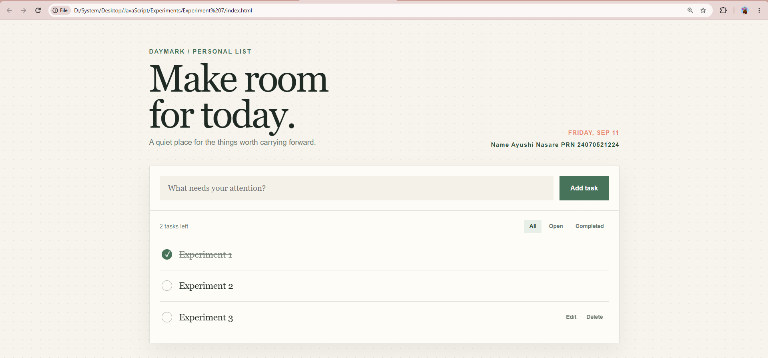

Case Study Title: To demonstrate the Events Handling in JavaScript.
a) Access and manipulate form elements using JavaScript.
b) Validate user input (e.g., email, empty fields).
c) Use Various form events (submit, change, focus)
Create the following html form and use required JavaScript and events in a given form
Case Study Program Code:
index.html
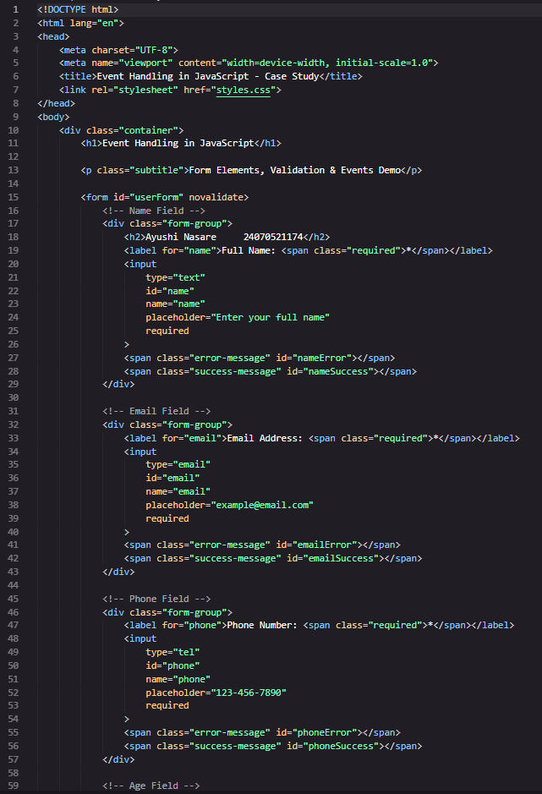
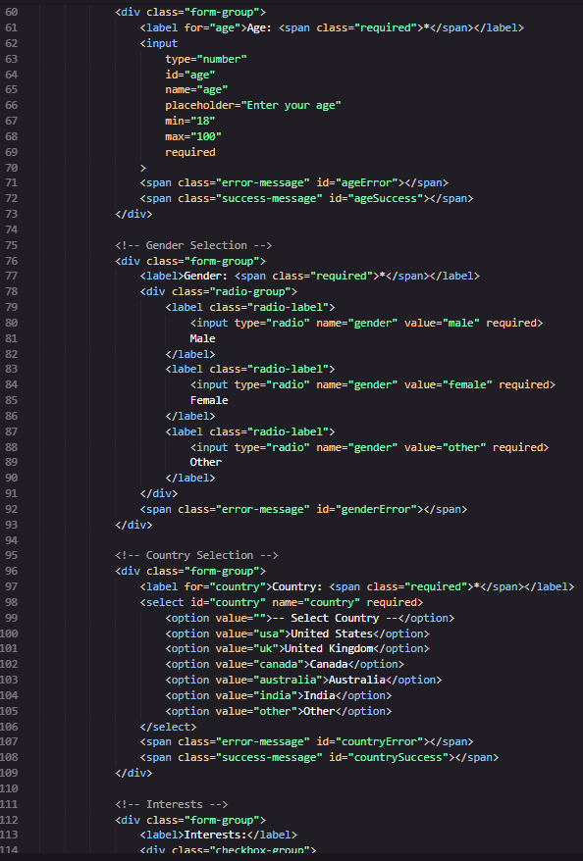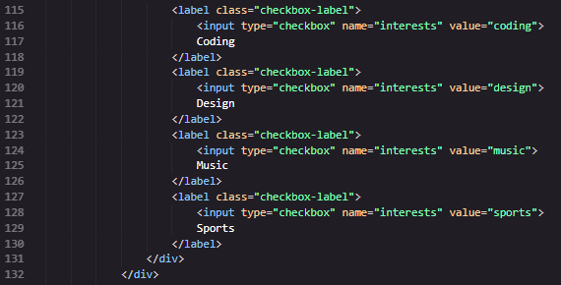
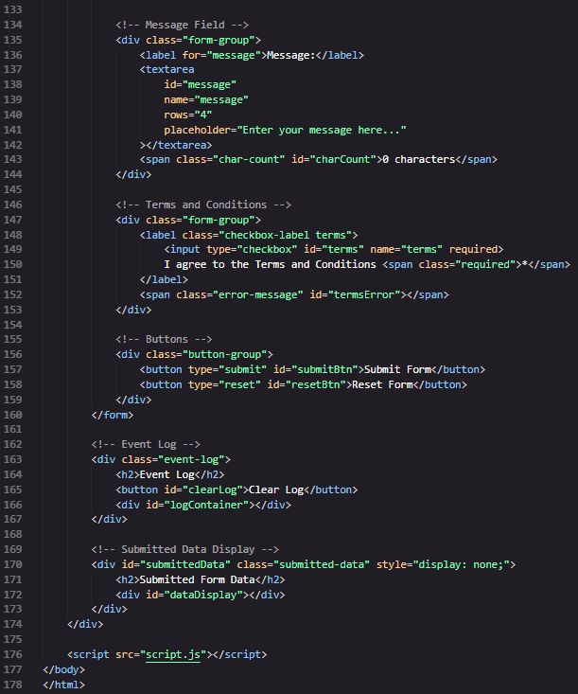
style.css
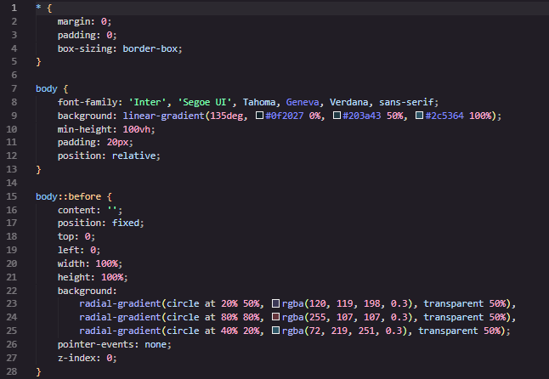
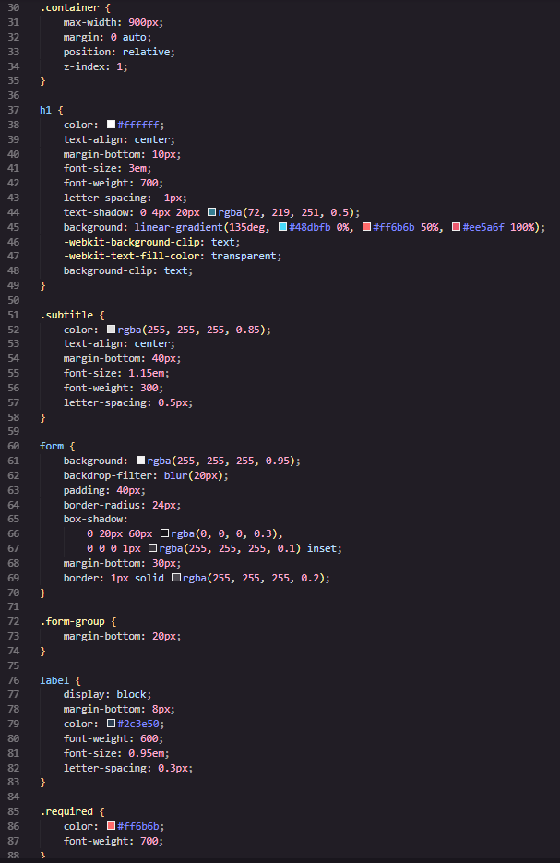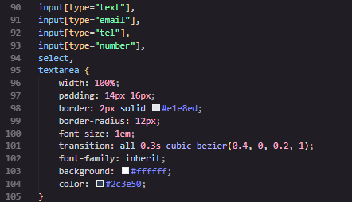
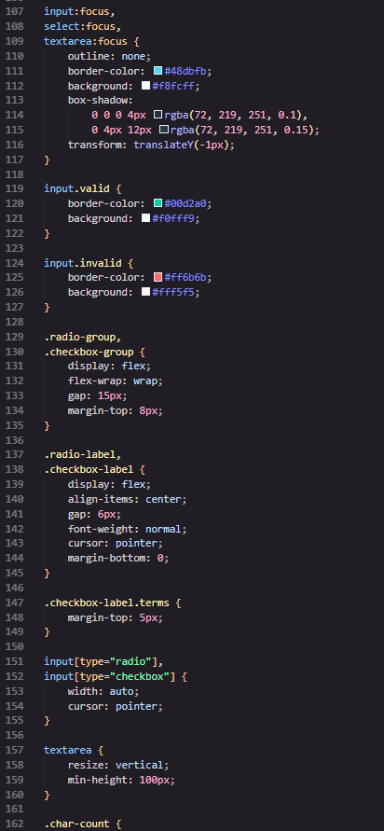
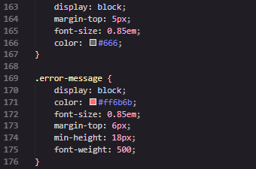
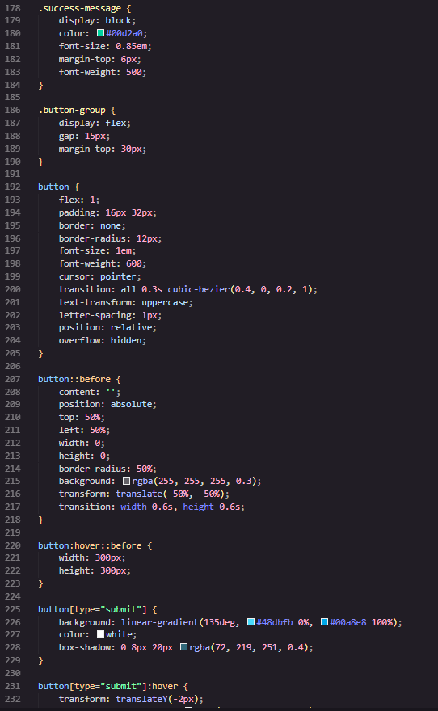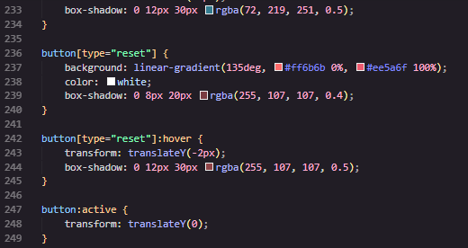
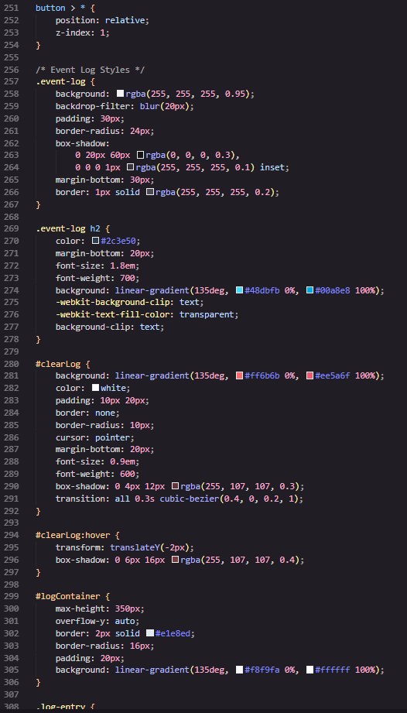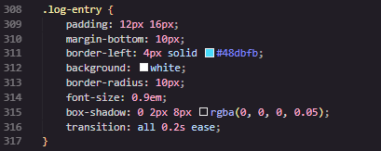

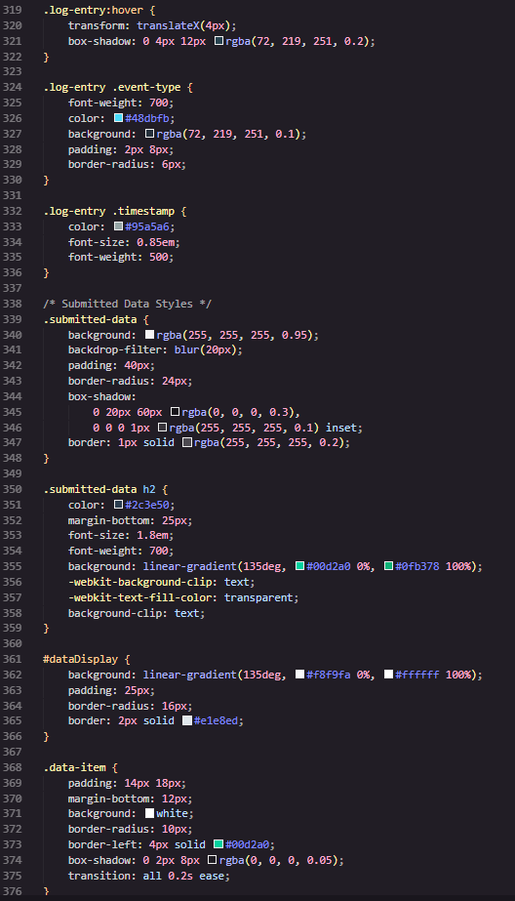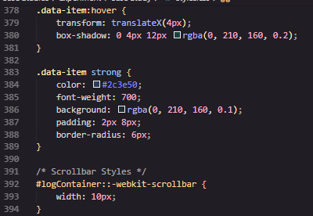
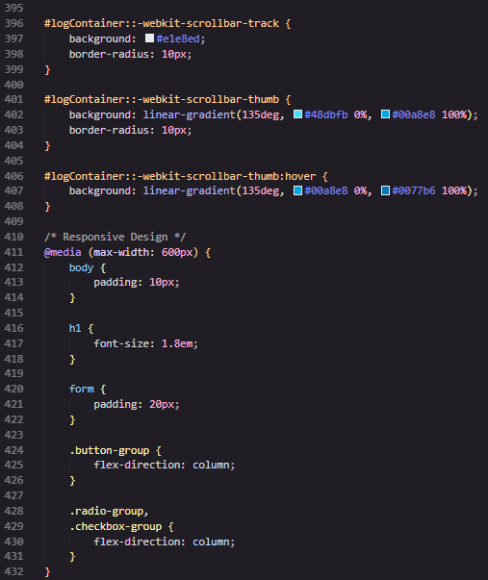
script.js
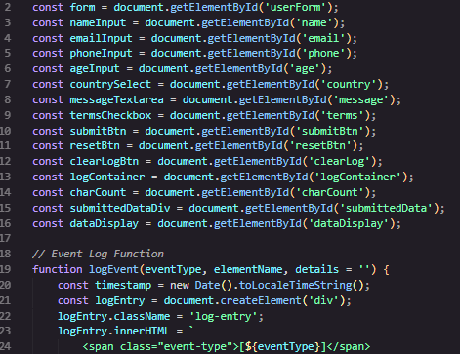
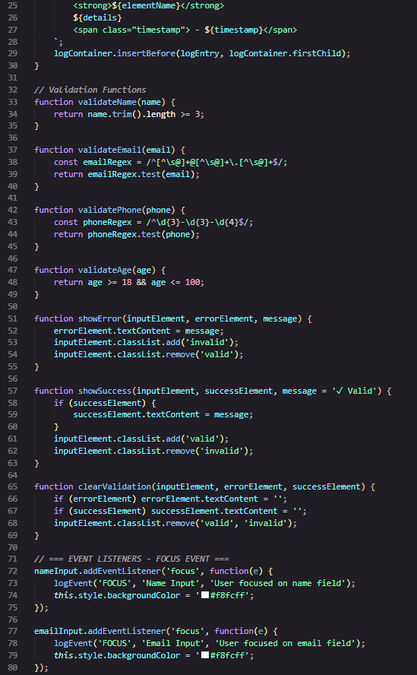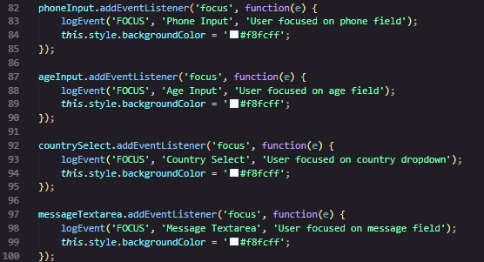

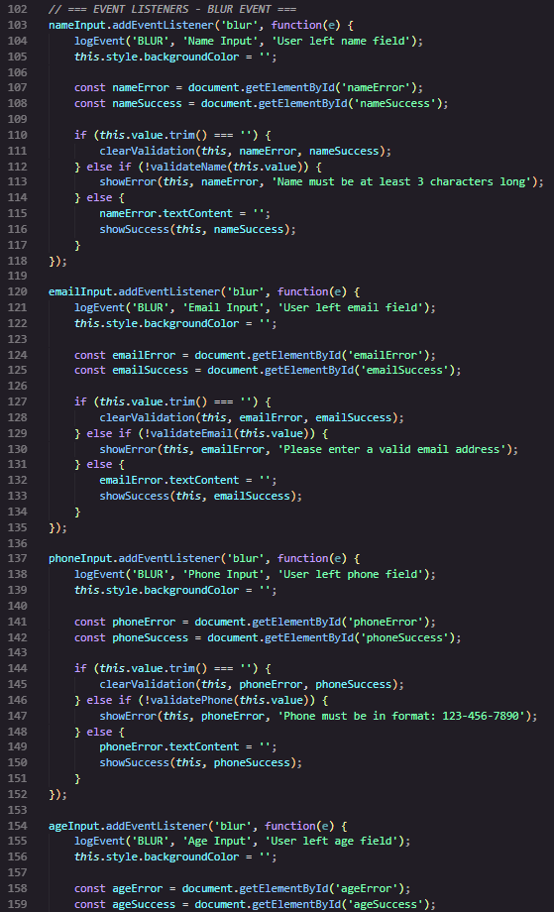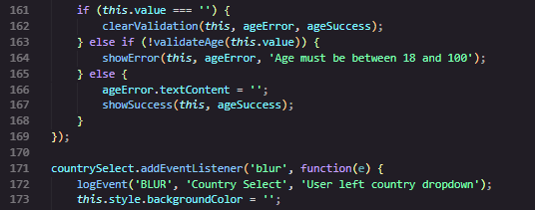
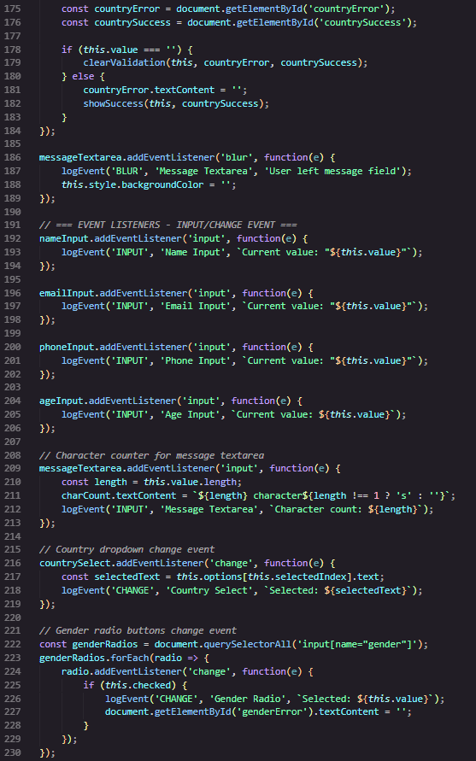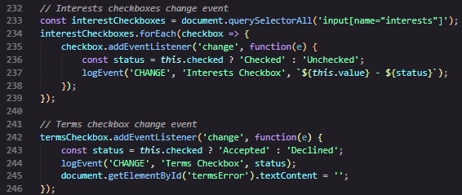
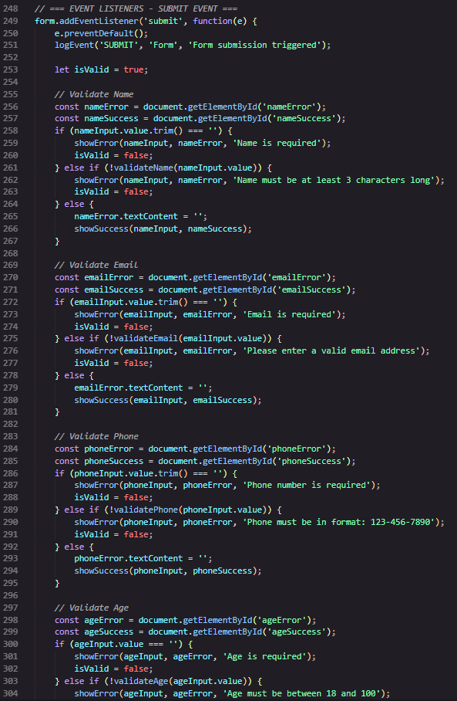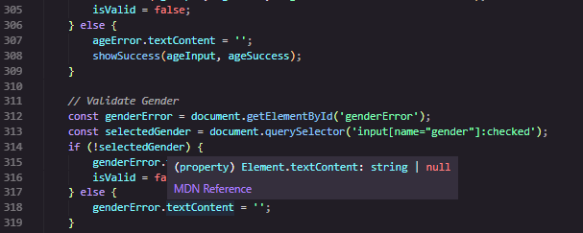
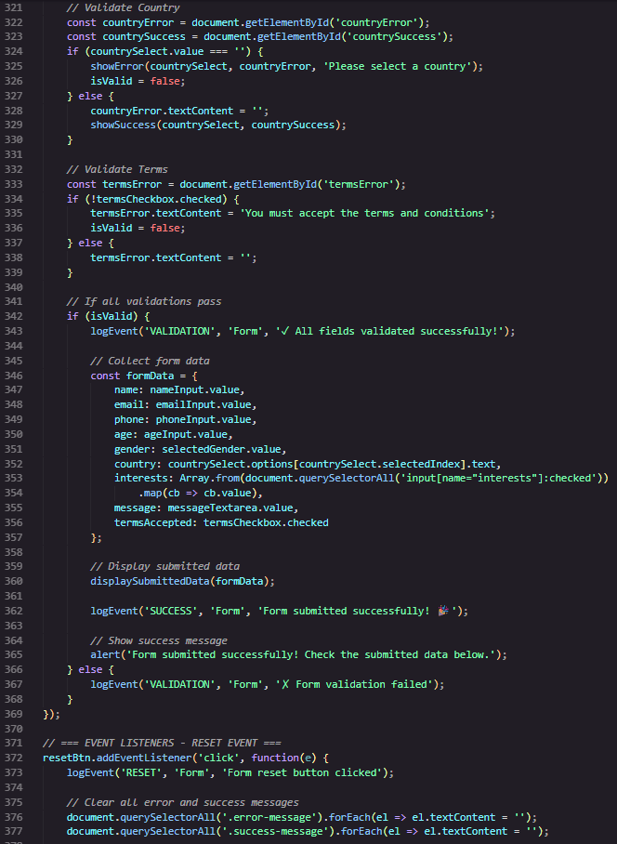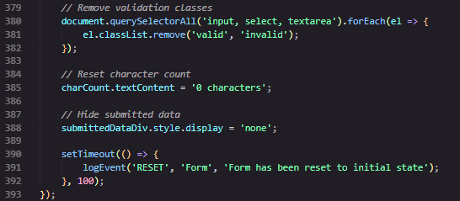

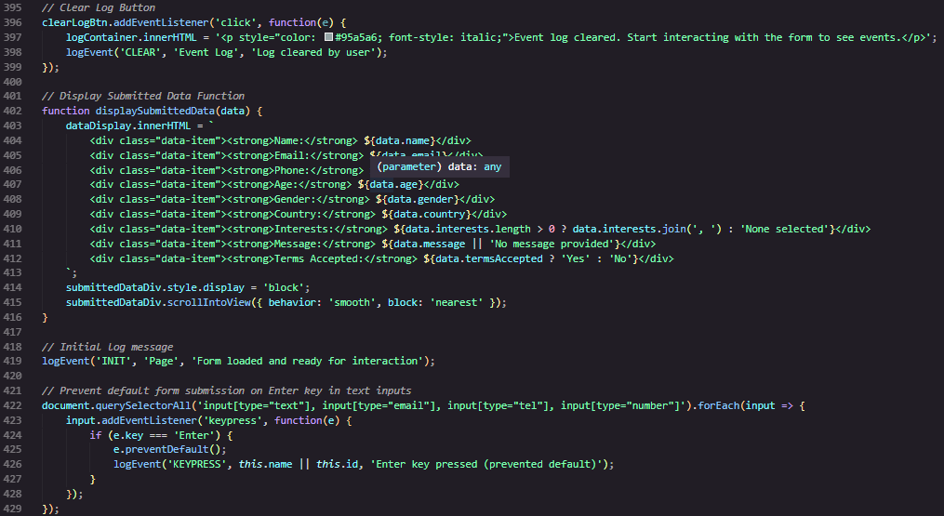
Output:
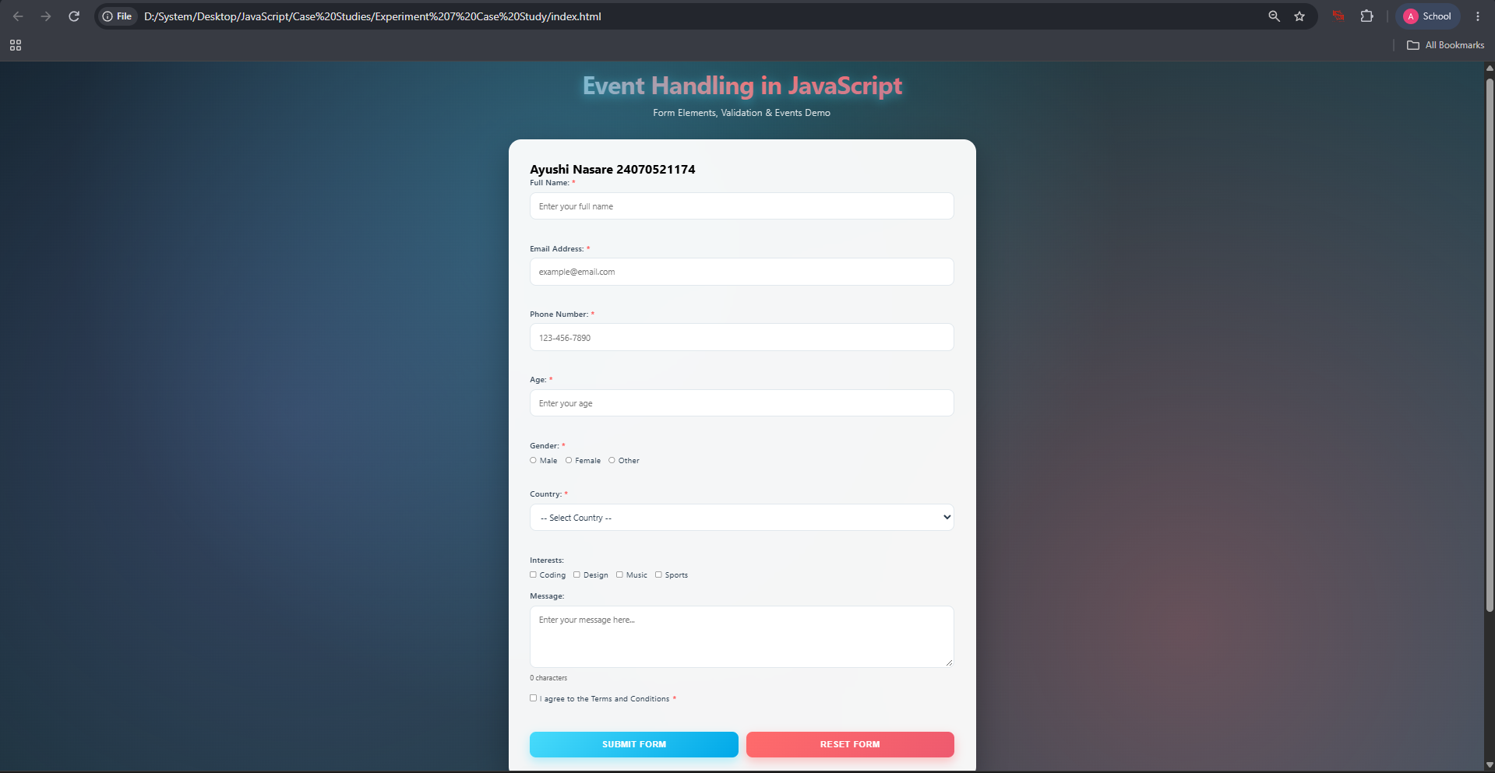

Experiment No. 8
Experiment Title: Access and validate form fields using events; design a gym admission form with live input checks.
Software/Tools Required:
- Visual Studio Code (VS Code)
- Google Chrome
- HTML5
- JavaScript
Experiment Program Code:
index.html
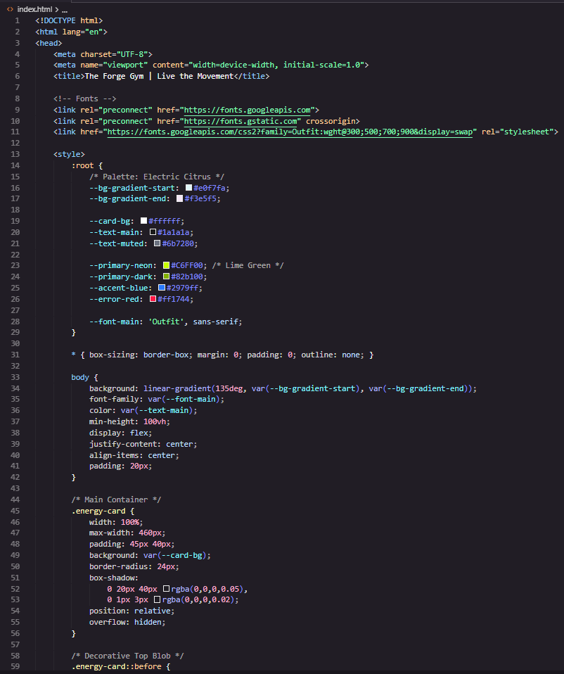
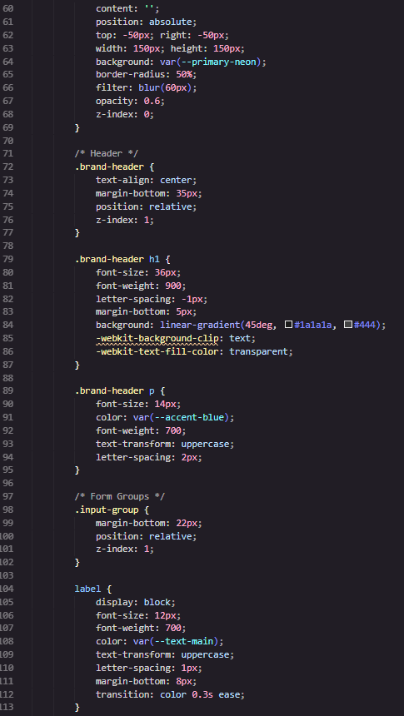

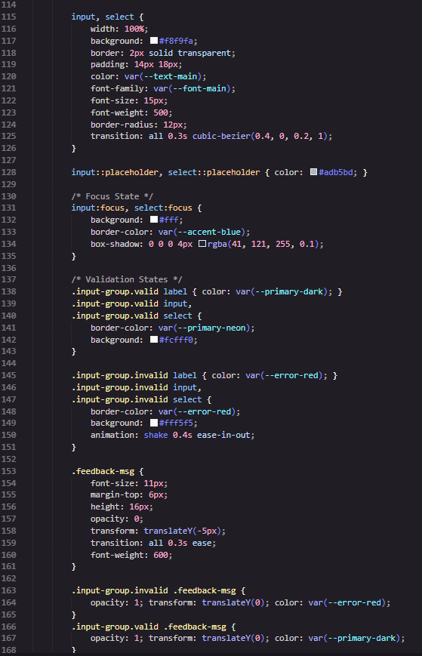

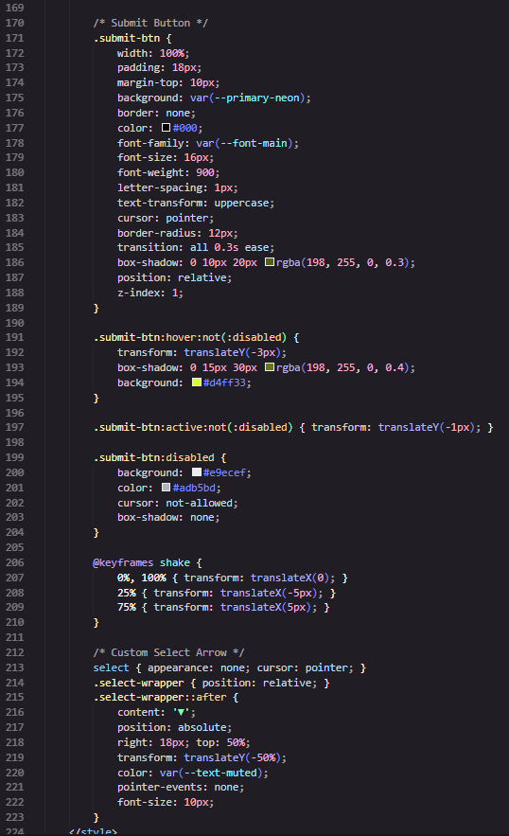

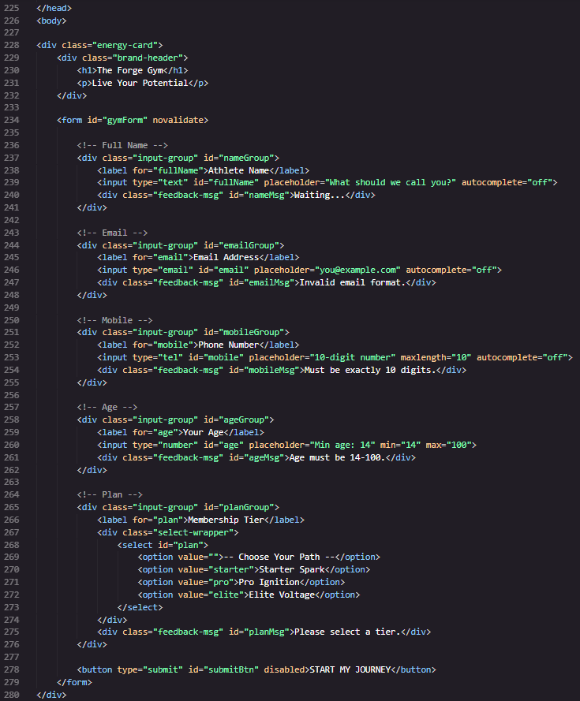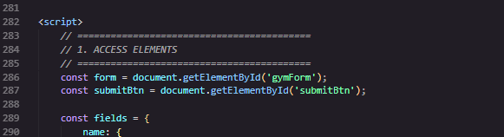

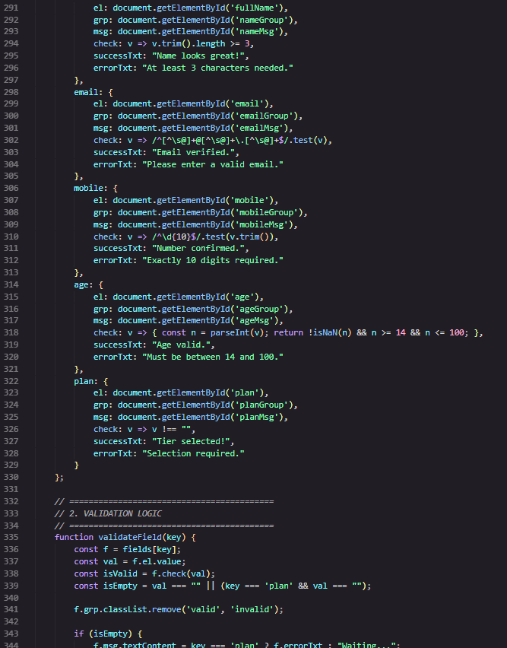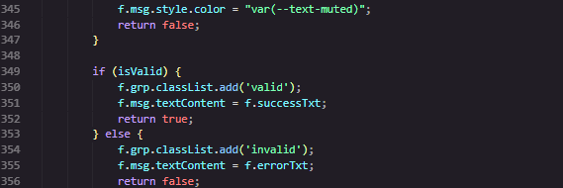
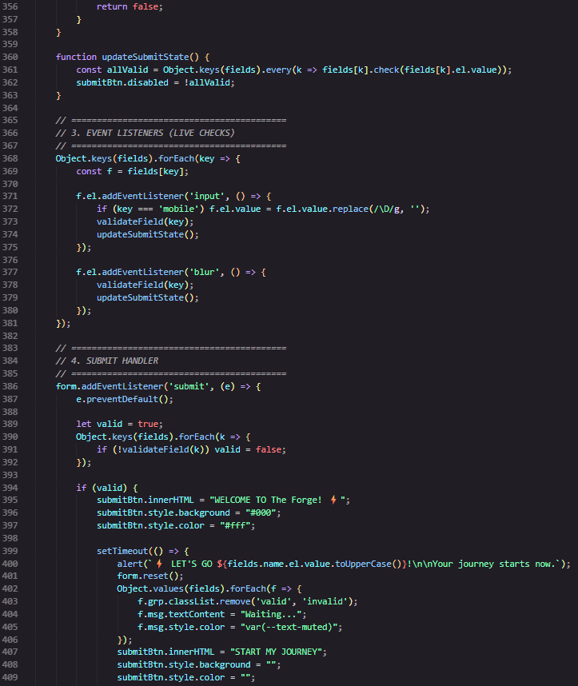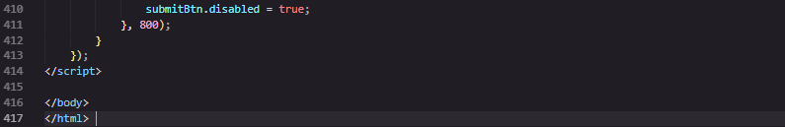

Output:
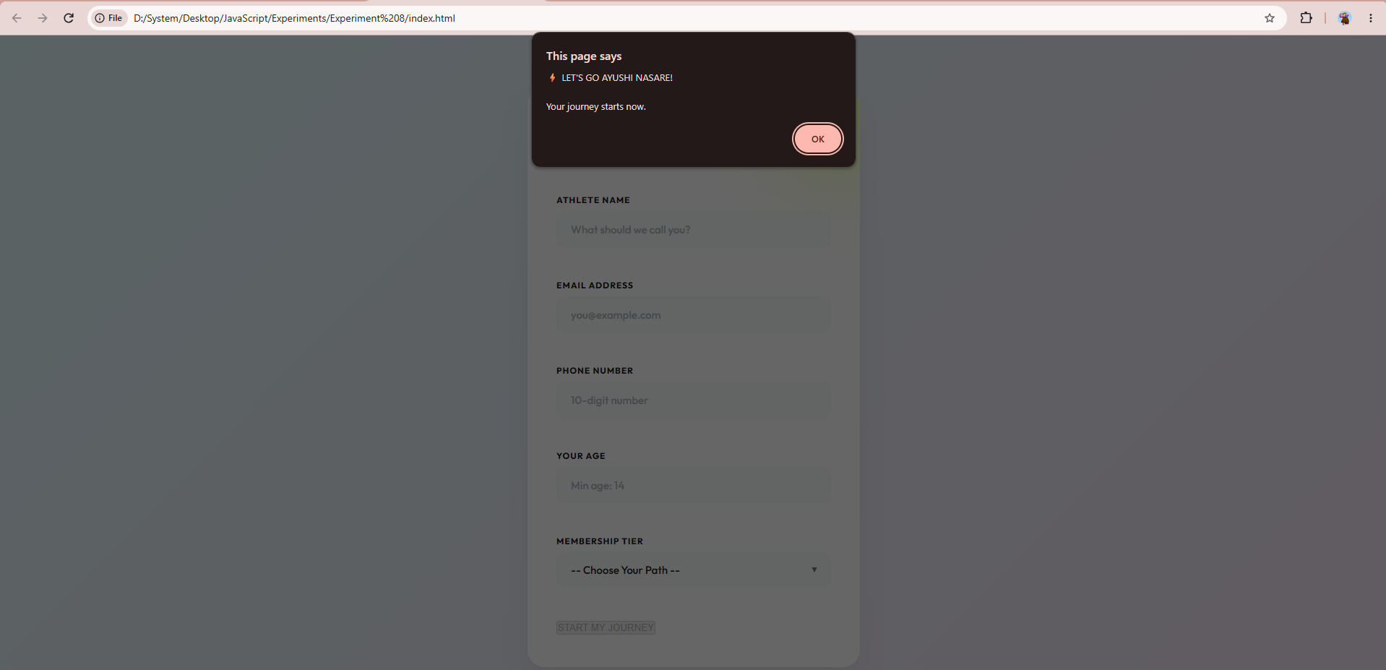

Case Study Title: Online Job Application Form
Case Study Program Code:
index.html
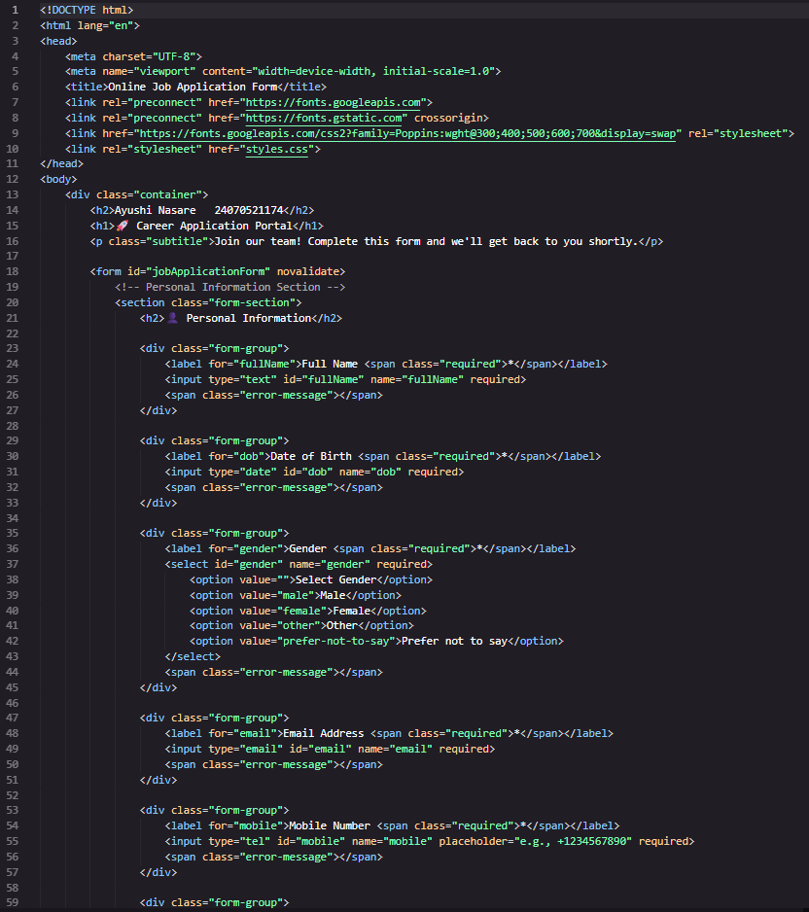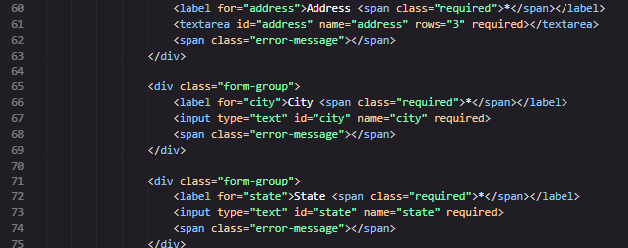
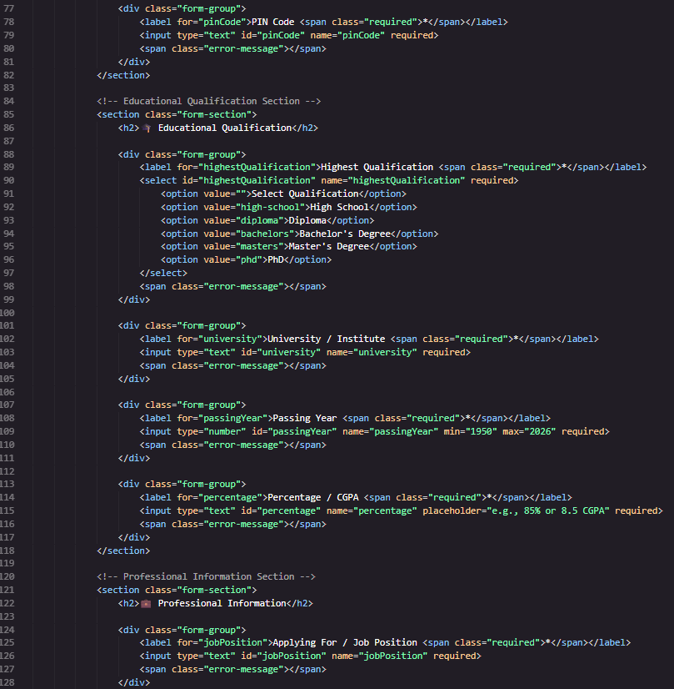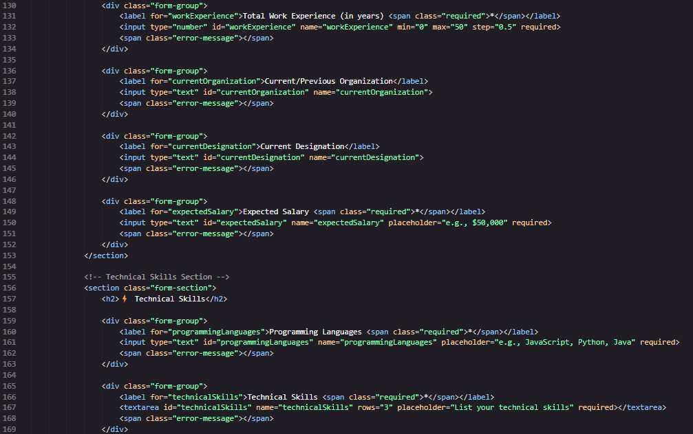

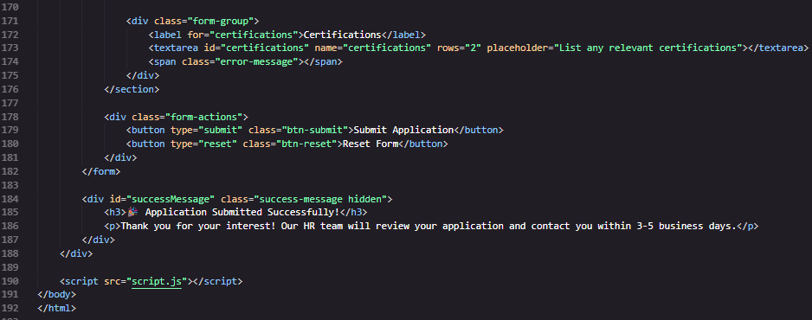
style.css
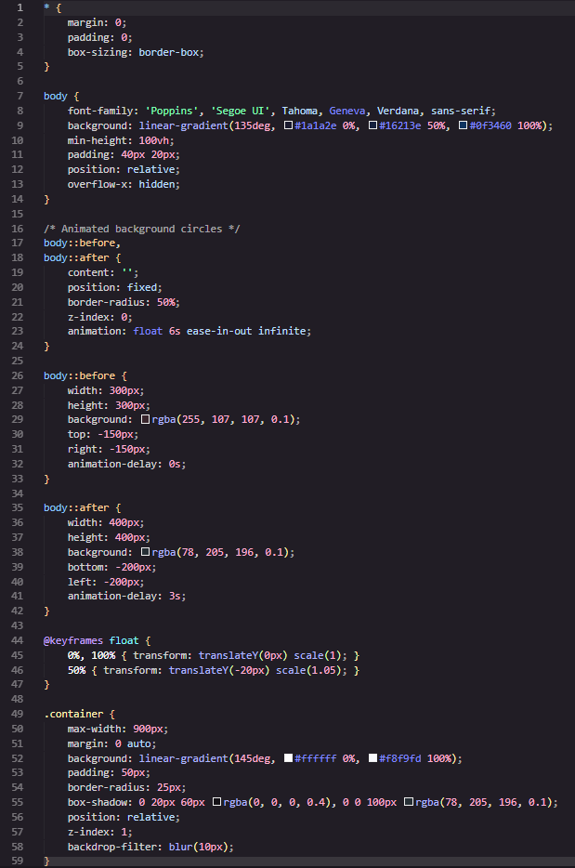
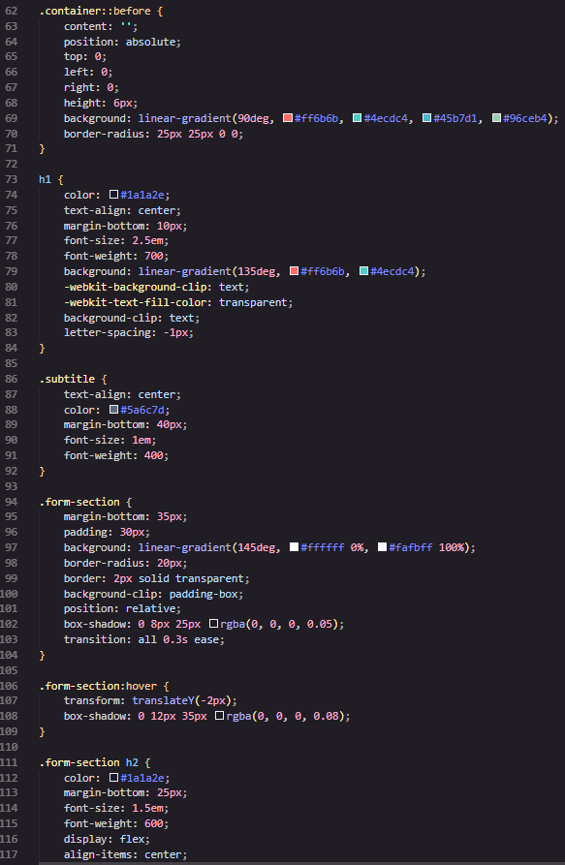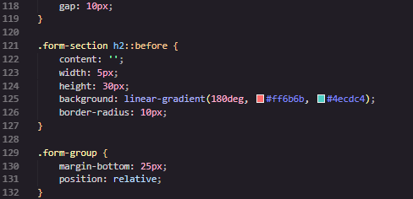
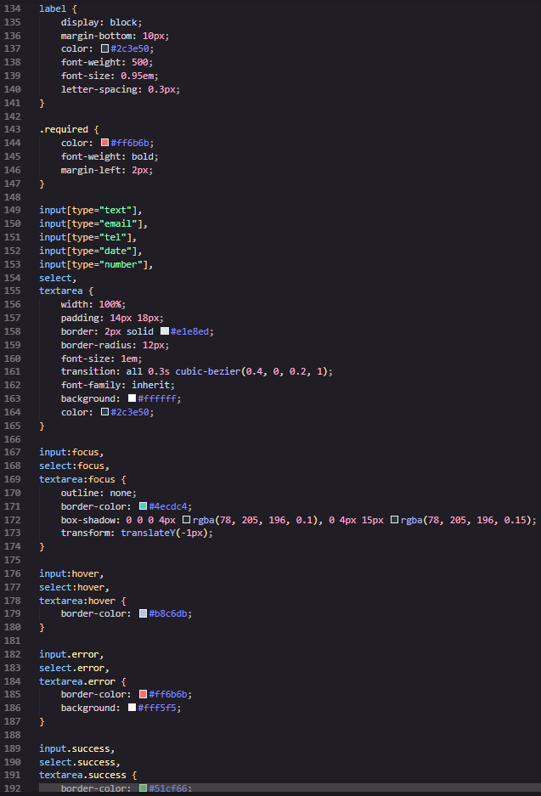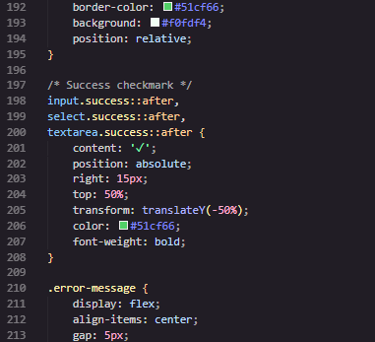
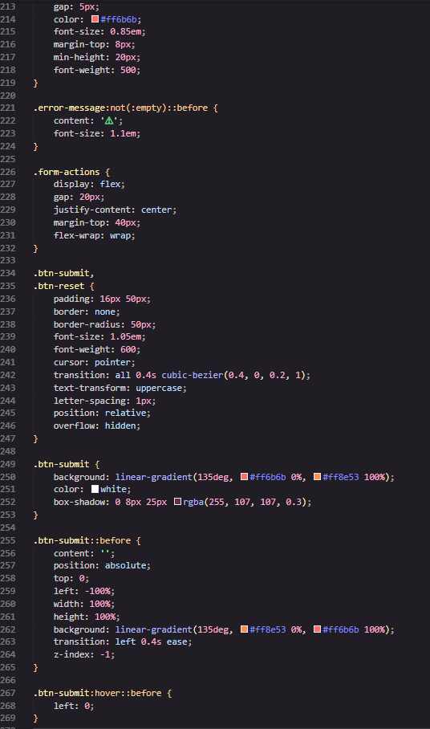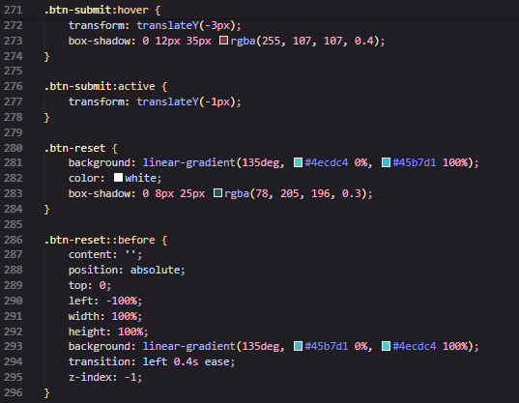
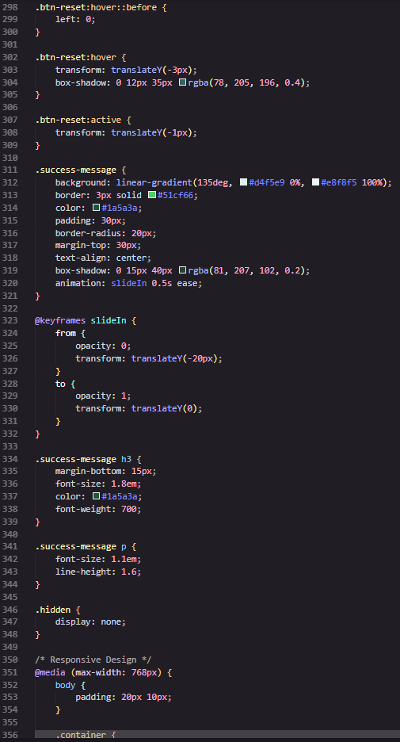
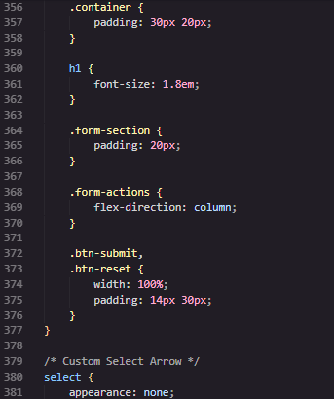
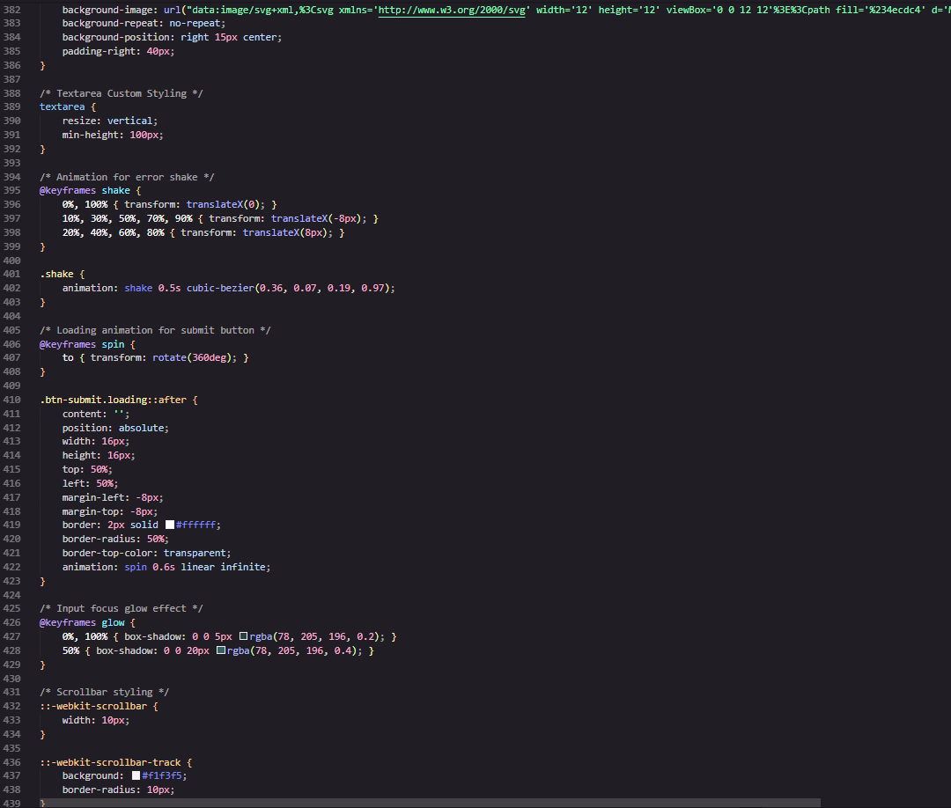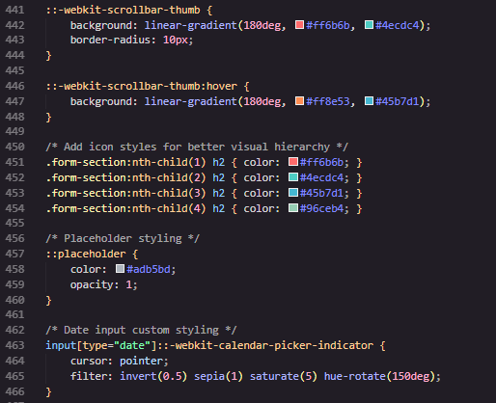
script.js
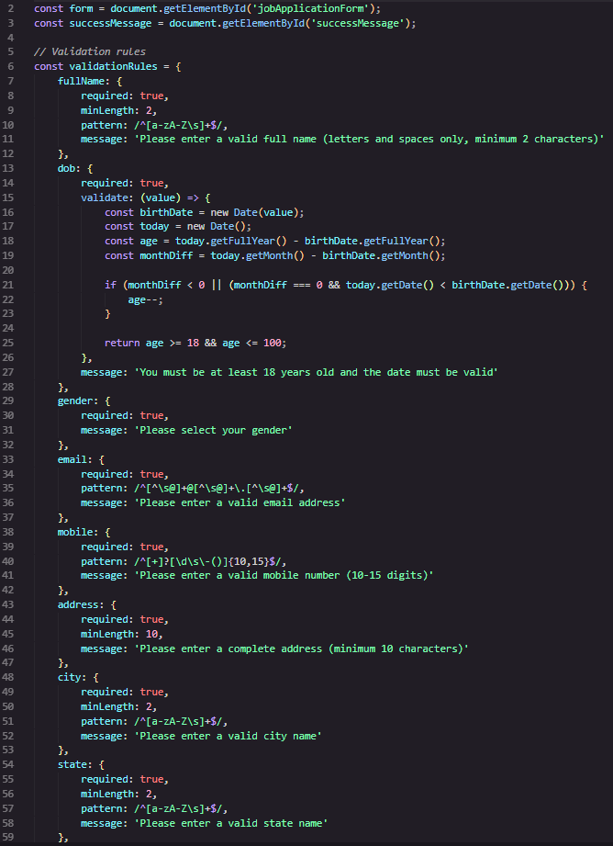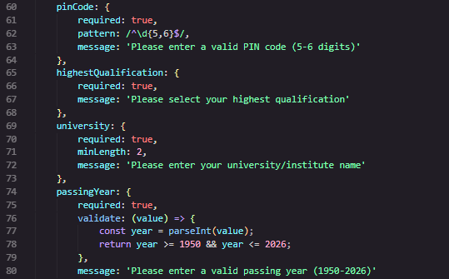
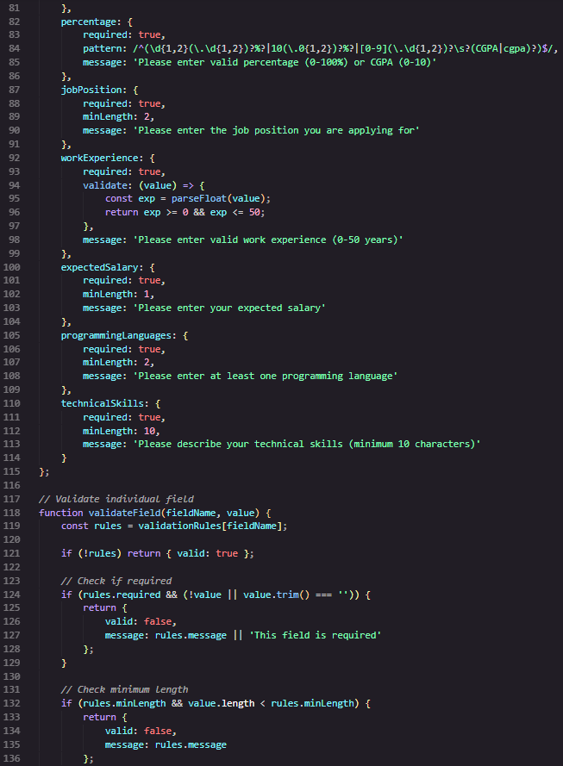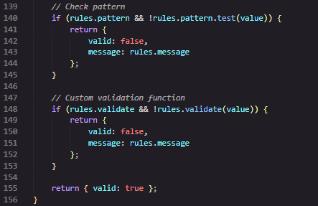
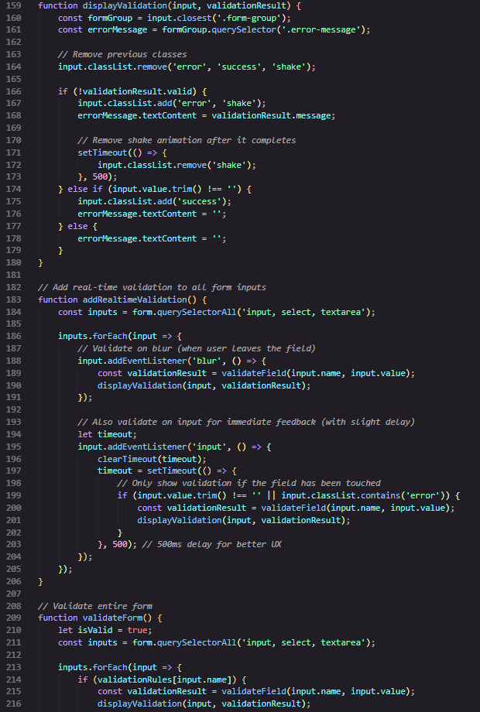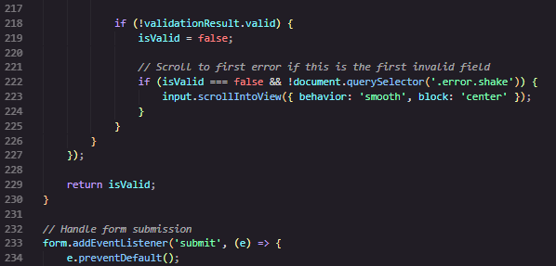
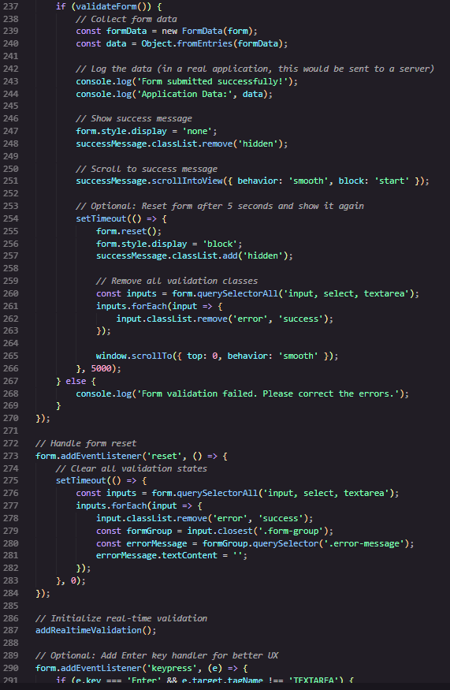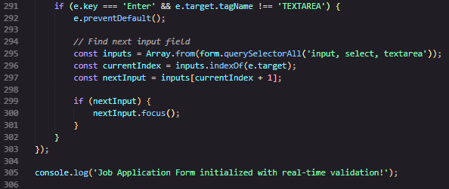

Output:
